Report of | Meeting | Date
Director of Communities  (Introduced by the Cabinet Member (Communities, Social Justice and Wealth Building)) | Cabinet | Wednesday 15 December 2021
Is this report confidential? | No
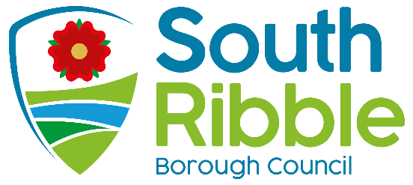
Is this decision key? | No

Update on the Review of Community Involvement

Purpose of the Report
- To provide Cabinet with an update on the work of the Communities Service, including progress on the Review of Community Involvement.

Recommendations
- Cabinet is asked to note the work of the Communities Service

- Cabinet is asked to note the evaluation of Community Hubs and agree the continuation of the current model

Reasons for recommendations

- This report follows on from the update provided to Cabinet in June this year. In addition to providing a position statement on the progress of community hubs in relation to the cross-party review of community involvement, a snapshot of wider work across the Communities Service is offered.

Other options considered and rejected
- This report provides a second update report for the Council’s Community Hubs in 2021/22. It complements quarterly corporate performance reports, but relates more specifically to progress around recommendations from the cross-party review of community involvement.

Corporate outcomes
- The report relates to the following corporate priorities:
An exemplary council |  | Thriving communities
A fair local economy that works for everyone |  | Good homes, green spaces, healthy places

Background to the report
- The Council’s Communities Service offers a range of functions across Community Development, Community Safety, Active Health and South Ribble Together teams.

Community Development | Active Health | Community Safety | South Ribble Together
Community Hubs | School Games | Safeguarding | Vulnerable resident casework
Boost Fund | Schools Buy-Back Offer | Anti- Social Behaviour
Mental Health |  |  | Community COVID response
Youth Council | Wellness Services | Community Safety Partnership
Social Isolation | Bikeability |  | South Ribble Together Network
Health Inequalities | Healthy Weights | Police Liaison
Foodbank Network | Bike Hub | South Ribble Integrated Team | Community Digital support
Volunteering | Business Health Matters
Schools Liaison |  | Domestic Abuse | Central Lancs Health Project
Armed Forces | School Holiday Schemes | White Ribbon Accreditation
Employability |  |  | Household Support Fund
Emerging themes: refugee & asylum seeker programme, support to friends groups, social prescribing

- Five Member-led Community Hubs continue to operate across the Borough, each with its own action plan, containing projects to deliver local priorities. Action plans have been created in consultation with members at planning meetings, based upon their understanding of priorities in their wards. Area profiles have been drawn up to ‘tell the story’ of each hub area, based on statistical data and local knowledge, to help members determine local need.

- Projects are delivered on an ongoing basis in all of the Community Hub areas. Action plans remain ‘live’ and are updated as projects are completed.

- Cabinet has committed to a period of twelve months, during which time each Community Hub is being asked to consult on, design and develop its own model of community engagement, develop action plans, and to track its success.

- This report forms a summary of the work carried out by the Communities Service, and a status update on the Review of Community Involvement. Since the report of the cross party member working group was published, work has been ongoing to:

- Support listening to and engaging with our communities
- Develop locality working; strengthening links with groups and residents
- Be more intelligence led, with a better understanding of local issues
- Build trust with community groups; delivering on the ground
- Bring the Council’s priorities to life, with tangible results

Community Hub Action Plans

- Community Hub action plans are regularly monitored and discussed by members at planning meetings. Each project has a lead member, whose role is to champion and drive progress. Some of the highlights from current projects are summarised below.

- South Ribble in Bloom - a competition to encourage civic pride, promote healthy hobbies and add colour to our local area. Delivered virtually in 2021 to ensure COVID compliance, ‘Bloom’ attracted 45 households, groups and businesses to get planting and photograph the results. This project has evolved significantly, with involvement from residents of all ages and backgrounds now established. A celebration event on 14 October was well received and supported, with a great deal of excitement around reinstating a face to face competition for 2022.

- Farington Lodges – a longstanding, aspirational project which formed part of the legacy from the previous Neighbourhood Forum. Funding has now been successfully secured from the Lancashire Environment Fund, LCC’s Farington Fund and the internal Boost Fund. In total, this will resource a £55,000 improvement programme around the lodges which will make a significant difference to the quality of the site for new visitors and regular users alike. Priority works identified include refurbishment of footpaths, replacement of gates and rotten fencing, reinstatement of noticeboards, repairing / replacing seating, cutting back trees and installation of a new dipping platform.

- Eagle and Child Bowling Green – another longstanding project which Leyland and Farington Community Hub has brought to fruition. From an initial enquiry from the bowling club committee who were concerned about the sustainability of the site they occupied, this project has seen the Council purchase the bowling green from Marstons brewery. A long-term lease and self-management arrangement is now in place with the club, to safeguard its future and offer security of tenure. Through the hub and boost fund, much needed disabled access has been created with a new path off Balcarres Road.

- Lostock Hall War Memorial – members from the Bamber Bridge, Lostock Hall and Walton le Dale Community Hub have supported improvements to the Brownedge Road monument. A new ‘living wall’ has been created in ivy, with a dual purpose of improving air quality at the traffic lights, and screening off trade waste bins / cars parked in the adjoining alley. A site tidy up and planting scheme completed this project in time for Remembrance Day commemorations.

- Holland House Residents Association – in response to an approach by a group pf residents who wanted to look at ways to improve their local environment, the Bamber Bridge, Lostock Hall and Walton le Dale Community Hub has supported the creation of a new residents’ association for the Holland House estate. In addition to governance and action planning support, the hub has match funded a community defibrillator, installed on Walton le Dale FC changing rooms and registered with NWAS for public access.

- Two of Penwortham’s conservation areas – Rawstorne Road and Church Road lacked signage to identify their status. Boost funding matched with core funding from Penwortham Community Hub provided interpretation panels to explain the historical interest of each site, and black street name plates to increase recognition. Feedback and thanks has been received from neighbouring residents and St Mary’s Church representatives.

- Further to LCC work on the Broadoak roundabout in Penwortham, the community hub is proposing to create a landmark feature to welcome people. The theme of deer has been chosen, as wild deer are regularly spotted and photographed locally; willow construction and an accompanying wildflower meadow will create a naturally attractive design.

- Cricketers from Gregson Lane approached ward members with a request for help – their changing facilities were inadequate, to the point where their team was potentially being prevented from progressing through the league system due to the lack of changing facilities for visiting teams. An ambitious boost fund bid is enabling the purchase and installation of a new amenity, offering two team changing rooms and one for officials, toilets, showers and storage for goal posts. Once installed, this will be shared by cricketers and footballers from adult and junior teams, and makes the Gregson Green site more sustainable for sport in the long term.

- Pre-pandemic, Samlesbury Civic Society made contact with Eastern Parishes Community Hub, to explore ways of working together for the benefit of Samlesbury residents. Some initial work supplying hi-vis vests and litter pickers has led to an ongoing relationship. Two members of the society acted as community judges for South Ribble in Bloom, and War Memorial Hall where they are based was used as a community conversation venue.

Schools Liaison

- A cross-party member group is being established to look at ways we can engage with and support schools, as key stakeholders in our communities. Having evolved from a task group looking at school readiness, this now complements work with the new LCC model of Team Around the School and Settings (TASS.) Shared priorities for the TASS Locality Board and the new Schools Liaison group, which will inform an action plan, have been identified as :

- Enabling all children to be school ready
- Increasing the number of young people progressing to employment and/or training.
- Improving educational outcomes for children and young people who find learning more challenging.
- Supporting the mental wellbeing of children and families

- The concept of South Ribble Uniform Bank started with conversations between colleagues and community groups. There was clear potential for a project to recycle school uniform – lots of children had barely worn clothing, coats and shoes which they had outgrown, and some families were struggling to afford new items. Donations of new and lightly used school uniforms from residents were received, sorted, labelled and gifted to 118 families who needed a helping hand. Where there were not appropriate items available within the uniform bank and affordability was a barrier, grant funding was utilised to purchase new uniforms. We worked with local foodbanks and community groups to deliver this project, who each promoted the scheme to families. We are very grateful to the elected members who gave up their time to make this scheme happen.

- The Active Health Team have longstanding relationships with schools, based on services provided in school settings. A wide range of activities are delivered in and valued highly by schools in keeping children fit and healthy. Through the pandemic, the team has been flexible and resilient to maintain an offer to pupils when schools have been restricted and even closed. Service to schools include:

- Active travel – scootsafe, balance bikes, bikeability (learn to ride)
- School games festivals (whole day sporting events)
- Cluster competitions (sporting events between school teams)
- Young Leaders (training high school pupils to referee and officiate)
- Nutrition Mission – healthy eating education programme
- Dance from the Heart – borough wide roadshow
- Wellbeing Wednesdays – yoga and mindfulness sessions

- Earlier this year, Cabinet approved a budget to offer a Schools Digital programme; supporting schools with devices for home learning where provision was limited. The objective was to ensure that no child in South Ribble was prevented from learning through a lack of affordability. Working with schools and LCC colleagues, 151 tablets were purchased and distributed, with schools retaining ownership and maintenance responsibility.

- Excellent progress is being made in establishing a Youth Council for South Ribble, one of the recommendations from the cross-party review of community involvement. The review recommended that a Youth Council should be formed to actively involve young people in decision-making, local democracy and the services which affect them. Targeted at 14-17 year olds who want to learn about and have a voice in democracy, schools have responded well in promoting engagement with students,

Health and wellbeing
- A strong relationship with Lancashire MIND and provision of accredited Mental Health First Aid training has been recognised as a key aspect of our objective to be a supportive organisation to people’s mental wellbeing. It aims to equip people with the skills and knowledge to recognise when somebody is experiencing mental health challenges, and how to empathetically address this through conversation, and where to refer people for support.

- These courses have been delivered internally to three cohorts by Lancashire Mind, consisting of 1 elected member (Cabinet Member for Health & Wellbeing) and 41 officers from services which regularly have contact with residents who may be vulnerable. This work is forging a strong partnership with Lancashire Mind, who we recognise as a key local mental health partner, with them funding 32 of the 41 spaces to date.

- A series of Mental Health Community Awareness Sessions are being delivered around South Ribble by Lancashire Adult Learning, open to anyone who wishes to attend. Each one is supported by a Community Development Officer, and focuses on:
• What mental health and mental wellbeing is
• Risk factors
• The impact on the individual, friends, family and employers
• Types of mental health conditions
• Treatment and support
- The Active Health team are corporate champions in the Council’s approach to good health and wellbeing. Significant external funding has been attracted for officers to deliver a range of lifestyle programmes, including:

- Healthy weights – referrals from GPs and health agencies for diet and nutrition support
- Business Health Matters – health screenings for employees to encourage self responsibility, reduce time lost to sickness absence and sustain healthy workforces
- Bikeability – teaching children and adults to ride bikes safely and confidently
- Community Hubs have produced various heritage trails, walking and cycle routes around the borough, designed to support the ‘move more’ agenda, offer an environmentally friendly, free to access leisure opportunity, and to promote civic pride as people learn more about where they live. Routes can be accessed at: www.southribble.gov.uk/walking

Developing resilient communities

- South Ribble Together has been established as the multi-agency community response to COVID, led by the Council. With Citizens Advice Bureau and DWP co-located in the Civic Centre, colleagues have been able to work together to support some of the most vulnerable residents in the borough. Over the last 18 months, this response service has:

- Provided over 1800 essential food parcels
- Supported over 1250 residents, many including whole families and many being supported on multiple occasions.
- Collected and delivered over 590 prescriptions
- Delivered over 1390 case management sessions, including welfare calls, advice calls and welfare visits.
- Over 400 residents supported to access additional support

- Casework for South Ribble Together continues, as people are still feeling impacts such as redundancy, Universal Credit changes or ongoing poor health. Officers work with partners on a social prescribing type model, to ensure that vulnerable residents are able to access as much help as possible. Use of grant funding such as the DWP Winter COVID grant has supported 59 households with payments on energy (gas, electricity, water), white goods and cleaning / personal hygiene products.

- Utilising external funding from a population health management project, the communities service has recently employed a Digital and Community Co-ordinator. The purpose of this post, over a 12-month fixed term period, is to offer skills development to community groups, third sector organisations and Parish Councils, to help them make better use of digital devices and online services, and support their communities to do the same. This support will include, but not be limited to:

- Accessing and using digital devices
- Setting up and using social media
- Setting up and using websites
- Transitioning to digital customer management systems
- Using Microsoft Office
- Creating promotional materials via photography and video
- Using digital to attract new volunteers Digital and community offer

- On an ongoing basis, the Council supports voluntary groups who are valued partners in our local areas through the Communities Service. Examples include:

- Tippytoes Babybank – provided with temporary accommodation
- Community Network and Outreach Service – funding for parent and baby group and winter warmth project
- The Place (Wade Hall Community Association) – offered temporary storage and winter warmth project, Holiday Hunger delivery partner
- The Base at Broadfield – emerging partnership at Broadfield Community Garden, Holiday Hunger delivery partner
- Age Concern – provided with freezer space during lockdown
- Foodbanks – supplied with food and transport to share stock

Reducing Social Isolation

- The Council is committed to supporting those living with dementia and their carers, as a Dementia Friendly Borough. The local Dementia Action Alliance which supports this work is supported by members and a Community Development Officer. Recent achievements include:

- Creating the Peace Garden – dementia friendly design, planted by Leyland Bloomers
- Regular Dementia Friends sessions offered (virtually and in person) to raise awareness. Recipients include staff, members, local residents, businesses
- A joined up approach to Dementia Action Week with Chorley Council - a timetable of activities across both boroughs
- Event for World Alzheimer’s Day in partnership with Leyland United Reformed Church, including drop in service for advice and support
- Production of a Digital Inclusion Pack – a booklet for people with memory difficulties, for assistance and reassurance when using the internet.
- Facilitating consultation with people living with dementia for Leyland Town Deal and Central Lancashire Local Plan

- A cross-party member task group has been established to look at ways we can further expand on our efforts to reduce social isolation. Work on the South Ribble Together COVID Hub has demonstrated that loneliness and isolation can affect people at all stages of life, in lots of different circumstances. An action plan will be drawn up and delivered over coming months; initial priorities have been identified as:

- Working with community groups to establish provision for men (current provision has a much higher uptake from women)
- Mapping existing provision to understand what exists and what the gaps are.
- Raising awareness of available support amongst those at risk of being lonely e.g. via Council Tax bill mail out, working with Progress Housing

- The Active Health Team has been doing some innovative work through the Bike Hub, based at Withy Grove Park in Bamber Bridge. Officers based there have qualified as bike mechanics, enabling them to service and restore donated bikes, and train others in bike maintenance. The Bike Hub offers:

- Free bikes to those on very low or no income
- Tuition and ‘led’ rides to build confidence
- Planned ride schedules to increase fitness and stamina, e.g. routes for weekly rides, longer each week
- Several of the Community Hubs have already, or plan to install ‘happy to chat’ benches. These are essentially benches with a plaque to encourage people to make friendly conversation with others who sit there. With positive feedback already received, members are encouraged at planning meeting to identify locations in their wards where this approach may work well.

- Resocialisation cafés - using funding provided by the Clinical Commissioning Group through the Central Lancashire Covid Vulnerable project, two resocialisation cafes have been established in each of the of the Community Hub areas, aiming to build confidence and reduce social anxiety as people re-integrate back into the community following long period of social distancing. Each of these cafes have seen high levels of attendance and received excellent feedback. Funding provided to community groups has been welcomed after months of limited income due to COVID.

Tackling Food Poverty

- The Council’s Holiday Hunger scheme was established to ensure that no children go hungry during the school holidays, where families struggle to keep tummies full without the support of free school meals. During the pandemic, the method of delivery has been adapted, working in partnership with schools and community groups to ensure food parcels reach families.

- Each food parcel contains enough ingredients for a minimum of 5 meals, with average contents of cereal, tuna, cheese, hotdogs, pasta, pasta sauce, wraps, cordial, baked beans and instant noodles. All are provided with long expiry dates.

- Distribution to date is shown below. In the last year (October 2020 to October 2021), 13,954 parcels, or 50,975 meals have been provided.

 | No. of parcels | No. of meals
Oct-19 | 83 | 415
Dec-19 | 330 | 1650
Feb-20 | 228 | 1140
Apr-20 | 906 | 4530
May-20 | 352 | 1760
Aug-20 | 1500 | 7500
Oct-20 | 949 | 4745
Dec-20 | 2188 | 10,940
Feb-21 | 1101 | 5505
Apr-21 | 2288 | 11,440
May-21 | 563 | 2815
Aug-21 | 1810 | 9050
Oct-21 | 1296 | 6480
Total | 13,594 | 67,970

- Establishing a robust Foodbank Network is an important priority for the Communities Service. Through the Community Development Team, work is ongoing to support local foodbanks to become more sustainable, more specifically this includes:

- Implementing robust, efficient, and GDPR compliant processes
- Registration with Environmental Health, and food hygiene training for volunteers
- Improving collaboration and information sharing through a foodbank network
- Developing their model to provide a ‘Community Shop’ approach, as an alternative means of accessing foods and essentials, where individuals can receive items for a token payment. This offers users more dignity and a more sustainable option than foodbank reliance.

- Holiday and Food (HAF) Programme – the 2021 summer HAF programme was delivered by district councils across the county, using grant funding from the Department for Education. Using a combination of community venues, parks and leisure centres, children aged 4-16 were engaged in a wide range of activities –sports, martial arts, fitness and dance sessions, nature trails, arts and crafts were all offered.

- Although priority was given to families whose children received free school meals, we recognise that there are lots of families who need support, so no child was turned away from taking part in our activities and enjoying a healthy lunch.

- Over the course of five weeks, we provided more than 5,200 places at some 350+ camps across the borough. More information, including feedback from parents and providers is contained at appendix 1. A second HAF programme is currently being planned for Christmas holidays - www.southribble.gov.uk/haf2021

Delivering key messages
- Supported by the Council’s Communications Team, newsletter templates have been created for each of the community hubs. Each hub publishes newsletters as it chooses, either on a seasonal basis, or around a particular theme. Feedback has been positive, with community groups and individuals sharing newsletters on social media. An example of a Western Parishes Hub newsletter as attached at appendix 2.

- Facebook pages created for community hubs have increased in traction, as new content is generated following the relaxation of COVID restrictions. Officers across the communities service now have the ability to post material, and members are beginning to actively share news to their own pages and networks.

- Community Conversations – since the launch of the initiative in June 2021, approximately 295 residents have engaged with us via community conversations. Following positive feedback, these events will continue to be delivered in different locations, collaborating with key partners such as the Police, Lancashire County Council and Progress Housing,

- The Co-operative Councils Innovation Network is an excellent resource for the Council in terms of learning from other authorities and sharing our story. South Ribble has had 4 best practice case studies published this year, accessible via: www.councils.coop/case_study_tags/south-ribble-borough-council/links

Evaluation of Community Hubs

- Recommendations from the cross-party review of community involvement, subsequently agreed by cabinet, centred around seven key areas:

Level of community interaction and engagement
Level of community development and volunteering
Promotion of co-operative values (self-help, self-responsibility, democracy, equality, equity and solidarity)
Engagement with young people
Strengthening the voluntary, community and faith sector
Delivery of community priorities through forum projects
Engagement with parish and town councils (where applicable)

- A summary of progress to date against each of these criteria by project delivery is attached at appendix 3. As face to face events and meetings begin to increase, the scale and pace of delivery will pick up further over coming months.

- All members have been given the opportunity to give feedback on Community Hubs via an online survey. 30 members responded overall, from a possible 49; a response rate of 61%. Engagement rates broken down by hubs were:
Community Hub | Responses
Leyland and Farington | 12 | 71%
Penwortham | 8 | 80%
Bamber Bridge, Lostock Hall and Walton le-Dale | 6 | 60%
Western Parishes | 2 | 33%
Eastern Parishes | 2 | 50%

- In response to ‘Do you feel engaged in your community hub?’

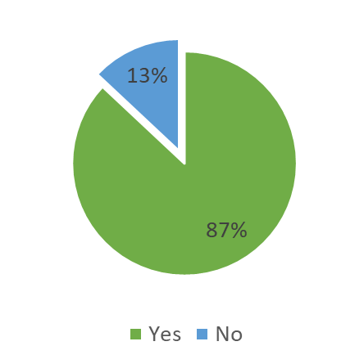 | If no, why not?
 | A lot of decisions are made without any discussion with members. We used to be very involved with community events but now I feel that events in particular, are being organised before discussion with ward councillors
 | I feel the current Leyland and Farington hub is very highly focused on Leyland, with Farington being particularly neglected.
We have much to do and it seems we cannot meet up often enough to sort it out.
The Boost funding is a little problematic as well as many of us are unable to furnish the need to find costs etc
 | I have shied away from coming to many community hub meetings as I feel I can add little value. In the past, I have raised issues and challenge, in my view appropriately, and been politely silenced.

- In response to ‘Do you feel like you can influence decisions made within your Community Hub?’

If no, why not?
YES & NO. Items on our neighbourhood plan can be discussed and influenced by our input but how can we influence the community events that are already in place before we are told about them
We need to look at a skills share/experience share/life skills from the members of the HUB…many councillors have hidden talents which may not be being used to their best advantage
I never seem to know when these are taking place

- In response to ‘Do you feel that you the decisions made within your Community Hub have a positive impact on the local area?

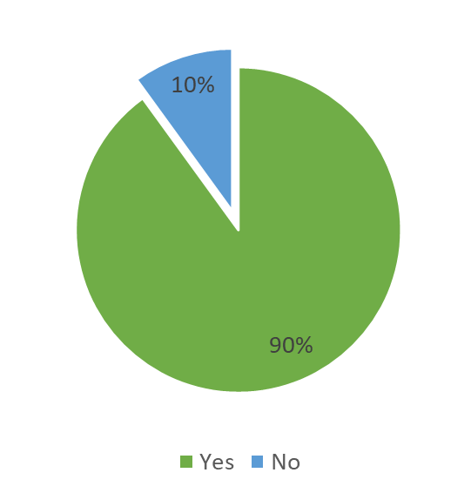 | If no, why not?
 | Some of them are. Some very good things are coming from our hub e.g. living wall in Lostock Hall, Happy to Chat benches in Bamber Bridge etc. Some of the existing events which were very successful are now non-existent. The monthly coffee and cake at Lostock Hall library was very successful, we spoke to more people there than any of the Neighbourhood events.
 | In the main yes but we do need to be flexible in where we support and help and we need to be careful are support is directed in the right direction.
 | The community hub concentrates particular areas within the hub and not the whole area. All Councillors need to attend the planning meetings so that projects can be brought forward and supported by the hub.
 | The hubs do have positive impacts with the projects they do, however as I have previously discussed, I feel not all areas receive a fair or equal proportion of attention.

- In response to ‘Do you feel that your Community Hub has the autonomy to identify and act on local priorities?’

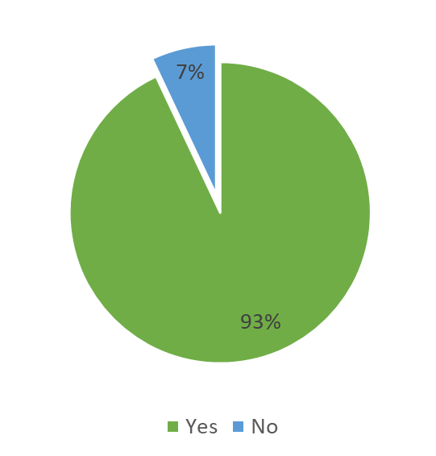 | If no, why not?
 | But we need to identify those local priorities and be very sure they are being acted on in an appropriate way. It isn’t a one size fits all… And we need to question ..do we have the skills and resources to fulfil our commitments.
 | The area of the hub is too large and has a large number of Councillors from different demographic areas so what may be a priority issue in part of the hub area may not be in another part of the hub. Projects that can benefit the whole area need to be a priority so that all councillors feel involved and can help to make a difference.
 | Not full autonomy. Need better control of the purse strings & decision making.

- In response to ‘Do you feel supported by the Community Development Team?
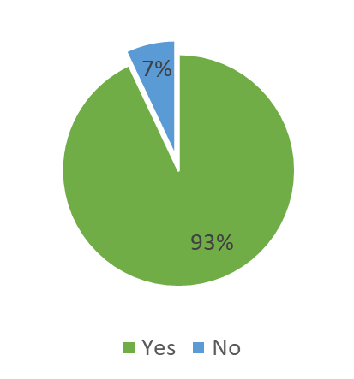 | If no, why not?
 | The support is there if we ask for it
 | No doubt about it…the Community Team have always given their best…..many times over and above…Thanks
 | The leadership of the team is good and the new team officer will be effective but we have not had a support officer for the hub since June so this has had an impact on the effectiveness of the hub
 | But lines of communication and discussion and actions then reflecting decisions made could be sharper

- In response to ‘What would you like to see improved within your Community Hub model?’ key themes were:
- More engagement with residents and increased resident involvement in community hub meetings and decision making.
- Improved alignment of projects with local need.

Member comments included:
Residents invited to community meetings whenever there is the opportunity, I have been asked several times when they will start up again
Would like to see priorities organised on an ‘issue basis’ e.g. Mental Health with projects attached rather than a list of individual projects.
More autonomy given to community groups to engage with us and their communities. Members of the community should be encouraged to speak to us directly more readily than they do at present
More contact between meetings
Quicker decision making and more direct engagement with our community.
The communication and working to improve conversations with the residents by regular forums, coffee mornings or other similar events, social events around the hubs different areas, working with friends and volunteers more so that residents feel they have ownership and benefit from projects in their particular area of the hub. Residents should be the heart of what happens in the hub and the members should facilitate project to benefit them as well as projects to improve the environment and the health and well-being of all residents in the hub’s area.
There needs to be more joint working, sometimes, it feels a little isolated
Better information about CIL money and upcoming discussions so that local priorities can be put forward in advance of agreements being made. Also increased speed and certainty around project funding (I am referring to elements outside of the boost projects as this is being handled very well already).

I would love to see the hubs become more autonomous, creating their own Terms of Reference and Constitutions which suits them in their own areas. I would also like to see Leyland and Farington invite a member of the youth council onto their hub and even other partners such as PCSO’s and other stakeholders.
I would like to see the hubs working towards projects which tie into the Corporate Strategy and intelligence from each area and where this crosses over I would like to see the hubs working together in a network.
I would like to see the hubs adopt and embed the principles of co-operatives that we have signed up to in the Co-operative Innovation Council

- In response to ‘What are your future ambitions for your community hub?’ key themes were:
- Better engagement with residents
- Delivery of projects which make a positive difference to the lives of residents

Member comments included:
To continue to focus on deliverable projects which have a positive impact on our area.
To continue listening and supporting the community
To deliver more successful projects with increased involvement with residents
To continue work on projects that directly benefit our community
I think the hubs should be able to change and evolve with the needs of the residents. Every proposal should be looked at carefully and considered in line with the council’s priorities but also the direction we are heading in terms of allowing the hubs to become autonomous. For example; if residents groups want grants to support their own work there should be a methodology in place for this to be considered. This is just one example of changes we should consider when asked.
A two-way dialogue with our residents and projects to improve the social fabric of the area.
A Hub that is involved in every aspect of life within the Hub area with which residents can identify work with. Where it can be seen that we are making a difference to people’s lives by enriching that sense of community.
To take the Hub out to the community more, engage directly with community groups, create opportunities for the community to work together
To be recognised as the community’s voice adding real value to the local area
Meaningful projects actions that benefit all but especially the health, welfare & lives of those that most need it in our community
To be more engaged with the community by greater awareness of the accessibility of members. To hold on to Louise Davies as our officer and deny her brilliance to other hubs! To encourage adequate resourcing of the officers supporting the hubs such as has been achieved by bringing in Reece to support Rebecca recently as we can’t afford to lose such excellent people or have them so swamped they can’t physically support us all.

- In summary, overall reactions were very positive:

- 87% of respondents feel engaged in their community hub
- 90% of respondents feel that they can influence decisions in their community hub
- 90% of respondents feel that the decisions made within their Community Hub have a positive impact on the local area
- 93% of respondents feel that their Community Hub has the autonomy to identify and act on local priorities
- 93% of respondents feel supported by the Community Development Team

- Officers in the community development team were asked the same survey questions as members, for comparison purposes. Key themes included:
- The feeling of mixed levels of member engagement across hubs
- Agreement that members can influence decisions in their community hub
- Agreement that hubs have autonomy to identify and act on local priorities
- Ambitions included more joined up working across hubs, clear terms of reference and more member involvement in communications and promotion.

Boost Fund
- The first round of Boost Funding, with a budget of £25,000 ran in Spring 2021. Hubs were invited to bid into this fund, designed for projects with positive, long-lasting impacts on communities. Applications were received to a value of £46,505.

- All bids received were awarded partial funding:

Hub | Project | Amount sought | Notes | Amount granted
Eastern Parishes | Gregson Lane changing rooms | £ 12,615 | 50% to be matched by hub | £ 6,307
BB, LH & WLD | Food bank premises | £ 14,500 | 50% to be matched by hub | £ 7,250
Leyland & Farington | Eagle & Child bowling green entrance | £ 5,000 | 50% to be matched by hub | £ 2,500
 | Farington Lodges | £ 6,650 | 50% to be matched by hub | £ 3,325
Penwortham | Conservation area signage | £ 2,040 | 50% to be matched by hub | £ 1,020
 | Mental health awareness | £ 5,700 | MH 1st Aid costs covered elsewhere | £ 900
Western Parishes | No bid received | £ - | - | £ -
TOTAL |  | £ 46,505 |  | £ 21,302

- The second round of Boost Funding closed on 31 October, with bids received from all 5 community hubs.

Hub | Project | Amount sought | Notes | Amount granted
Eastern Parishes | Winter Warmth | £ 4,000 | £500 per community group allocated, based on costs in Leyland & Farington. | £ 2,800
BB, LH & WLD | Love Where You Live campaign | £ 1,481 | To be delivered in January 2022. | £ 1,481
Leyland & Farington | Love Where You Live campaign | £ 1,481 | To be delivered in January 2022. | £ 1,481
Penwortham | Deer statue welcome feature | £ 2,937 | A more substantial installation would be preferred - option for the hub to match fund. | £ 6,000
 | Coach House Christmas carols | £ 1,270 | £200 cost estimate for refreshments may not be realistic - hub to fund any additional expenditure. | £ 1,270
Western Parishes | Garden Angels | £ 1,278 | To be aligned with Tempo volunteer time credits | £ 1,278
TOTAL |  | £12,447 |  | £ 14,310

- The Boost Fund concept has been well received by both community hubs and the groups who benefit. The remaining balance for 2021/22 is £14,388. Round 3 will close on 31 March 2022, for spring / summer project delivery.

Community Hubs Finance Update
- Funding available to community hubs for 2021/22 is made up of monies carried forward from previous years, combined with the annual budget which is based on the number of councillors.

Area | Carried forward | Core Funds | Total
Bamber Bridge, Lostock Hall & Walton le Dale | £33,098 | £5,500 | £38,598
Eastern Parishes | £9,784 | £2,000 | £11,784
Leyland & Farington | £25,151 | £9,000 | £34,151
Penwortham | £11,729 | £5,000 | £16,729
Western Parishes | £4,654 | £3,500 | £8,154
 | £84,416 | £25,000 | £109,416

- Community Hub spend to date in 2021/22 is shown below. Funding which has been agreed and committed to projects highlighted in grey. Match funding for boost fund bids has a B for identification.

Area | Budget | 21.22 spend / commitment | Amount | Total | Balance
Bamber Bridge Lostock Hall & Walton le Dale | £ 38,598 | Holland House Defib | £ 443 | £ 12,256 | £ 26,342
 |  | Church Road Gardens | £ 425
 |  | LH Station planters | £ 790
 |  | Living Wall | £ 2,680
 |  | LH Station planting | £ 148
 |  | Happy to chat benches | £ 520
 |  | Foodbank premises B | £ 7,250
Eastern Parishes | £ 11,784 | Gregson Lane changing rooms B | £ 6,307 | £ 6,787 | £ 4,997
 |  | Cuerdale Heritage Trail | £ 480
Leyland & Farington | £ 34,151 | Plants for Peace Garden | £ 1,420 | £ 11,493 | £ 22,658
 |  | Plants for Peace Garden | £ 288
 |  | Eagle & Child Bowling Club B | £ 5,000
 |  | Farington Lodges B | £ 3,325
 |  | CNOS Parents & baby group | £ 740
 |  | Friends of Leyland Station | £ 520
 |  | DAA banners | £ 200
Penwortham | £ 16,729 | Penwortham Live | £ 500 | £ 1,491 | £ 15,238
 |  | Conservation Area signage B | £ 1,391
 |  | Pumpkin Patch (refund from 2020) | -£ 400
Western Parishes | £ 8,154 | Longton Live | £ 500 | £ 1,248 | £ 6,906
 |  | Western Parishes Wheel | £ 238
 |  | Dob Lane benches | £ 510
 | £ 109,416 |  | £ 33,275 | £ 33,275 | £ 76,141

Risk
- The Communities Service produces a risk register annually, aligned with the business plan. In addition, individual risk assessments are carried out as part of project delivery.

- For Community Hubs, each of the projects contained in the action plans has an element of risk; through the scoping process and discussions with hub chairs and project lead Members, an assessment is carried out as to the level of risk and potential mitigation.

- Each project is scored against a matrix of measures which assess viability, value for money, scale of impact and the degree of community involvement in delivery.

Equality and diversity
- Projects delivered by the Communities Service and the Community Hubs are designed to be inclusive, accessible and bring communities together.
- Equality Impact Assessments have been carried out for each of the Community action plans; there are no potential negative impacts on any of the protected groups. There are specific positive impacts on age and disability, through projects such as reducing social isolation and sustaining our Dementia Friendly Borough status.

Air quality implications
- Air quality is regularly discussed in community hub meetings; members are committed to ensuring that we make every effort to promote environmentally friendly initiatives wherever possible. Projects such as the living wall, heritage trails, and Active Health work on cycling and promoting local sports opportunities all demonstrate this.

- Over the winter months work in Leyland, Farington, Bamber Bridge, Lostock Hall and Walton le Dale on a Love Where You Live campaign will help to disseminate the importance of clean air. Winter warmth packs in the Eastern Parishes will provide another opportunity to inform vulnerable residents of the importance of indoor air quality; of good ventilation and efficient use of heating systems, as well as carbon monoxide monitors, if appropriate.

Comments of the Statutory Finance Officer
- Finance information in relation to the hubs is as detailed above. Overall service financial performance is reported in the finance quarterly reports.

Comments of the Monitoring Officer
- There are no concerns from a legal perspective with what is proposed here. An evaluation of the working of Community Hubs has been carried out and the recommendation is that they should continue to operate in the same way.

Background documents
There are no background papers to this report

Appendices
Appendix 1 – HAF 2021 report
Appendix 2 – Western Parishes Autumn newsletter
Appendix 3 – Community Hub progress against review criteria

Jennifer Mullin
Director of Communities

Report Author: | Email: | Telephone: | Date:
Rebecca Heap (Communities Manager) | rebecca.heap@southribble.gov.uk | 01772 625276 | 19/11/21

