Application Number | 07/2021/00945/FUL
Address | 84 Hough Lane  Leyland  Lancashire  PR25 2YB
Applicant | Mr K Ali

Agent
Martin Spencer
47 Station Road
New Longton
Preston
PR1 0XH
United Kingdom

Development | Change of use of use of existing café/restaurant to a mixed use restaurant and takeaway (Sui Generis) together with installation of external ventilation duct
Officer Recommendation  Officer Name | Approval with Conditions  Mr Chris Sowerby

Date application valid | 14.09.2021
Target Determination Date | 09.11.2021
Extension of Time | 13.12.2021

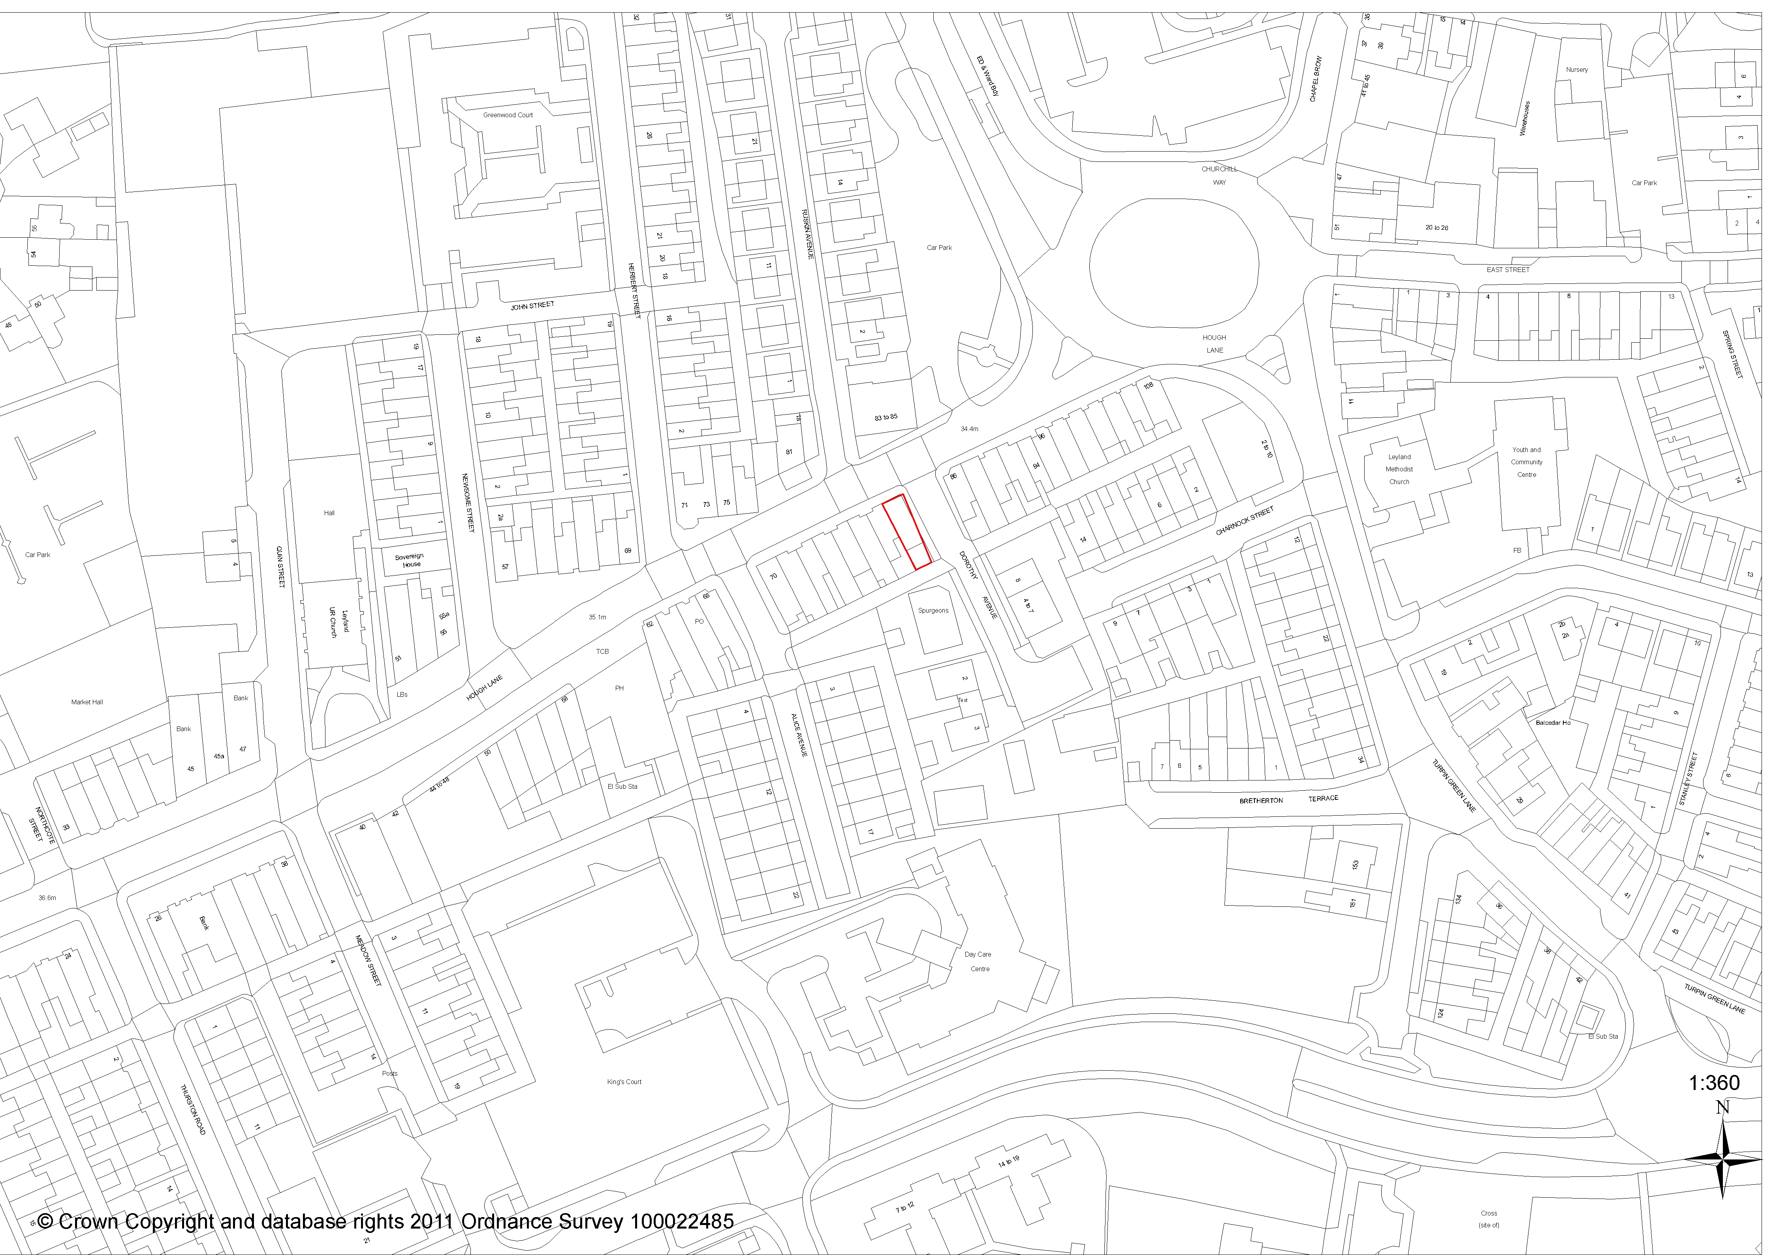

1. REPORT SUMMARY
1.1 The application relates to an end terrace premise which front Hough Lane within Leyland town centre which currently operates as a café (Dream Desserts), with a servery and takeaway area on the ground floor and a dining area provided on the first floor.

1.2 The premise is within the policy designation of Leyland Town Centre (Policy E3) in the South Ribble Local Plan, with a variety of commercial premises present along Hough Lane. Dorothy Avenue runs along the eastern side of the premise with an office present to the rear. On the eastern side of Dorothy Avenue there are residential properties.

1.3 Planning permission is sought for a change of use of the premise from a café/restaurant to a mixed use restaurant and hot food takeaway (Sui Generis Use Class) together with the installation of an external ventilation duct.

1.4 The proposed 0.3m diameter ventilation duct would be fitted to an existing flat roofed single storey extension with the top of the cowling to be set 0.5m lower than the roof ridge on the main building.

1.5 Policy E3 seeks to maintain and enhance the vitality and viability of Leyland town centre with specific regard given to enhancing the evening economy. With the proposal continuing to maintain a restaurant element to the business within the premise as part of the mixed use proposal the proposal accords with the requirements of Policy E3.

1.6 The only proposed change to the external appearance of the premise relates to the ventilation system on the rear. The ventilation duct would be lower than the ridge on the main building. The proposed ventilation duct is to be installed on the inner side of an existing first floor outrigger, which maximises the distances to residential properties on Dorothy Avenue. The property immediately to the rear and adjoining the premise are both in commercial uses. As such there would be only limited views of the proposed duct from Dorothy Avenue.

1.7 The proposed development is not considered to have a detrimental impact on the character and appearance of the area or the amenities of any nearby residential property and complies with requirements of Core Strategy Policy 17 and Policy G17 of the South Ribble Local Plan.

1.8 County Highways have raised no objections to the proposal, stating that the change of use would have a “negligible impact on highway safety and highway capacity within the immediate vicinity of the site.”

1.9 Environmental Health have also raised no objections to the proposal.

1.10 The proposal accords with Policies 1 and 28 of the Core Strategy together with Policies E3 and G17 of the South Ribble Local Plan. The application is therefore recommended for approval subject to the imposition of conditions.

2. APPLICATION SITE AND SURROUNDING AREA
2.1 The application relates to an end terrace premise which front Hough Lane within Leyland town centre.

2.2 The premise currently operates as a café (Dream Desserts), with a servery and takeaway area on the ground floor and a dining area provided on the first floor.

2.3 A variety of commercial premises are present along Hough Lane, with a dental practice present opposite. Dorothy Avenue runs along the eastern side of the premise with an office present to the rear. On the eastern side of Dorothy Avenue there are residential properties.

2.4 The premise is within the policy designation of Leyland Town Centre (Policy E3) in the South Ribble Local Plan.

3. SITE HISTORY
3.1 In 2016 planning permission (07/2016/1071/FUL) was granted for the change of use of the premise from A1 (retail) to A3 (cafe) together with new shop front and roller shutter.

3.2 Prior to this in 1978 planning permission (07/1978/0633) was granted for the change of use of the premise from an office to a confectioners shop.

4. PROPOSAL
4.1 Planning permission is sought for a change of use of the premise from a café/restaurant to a mixed use restaurant and hot food takeaway (Sui Generis Use Class) together with the installation of an external ventilation duct.

4.2 The internal layout of the premise is to remain as existing, with the kitchen, servery and takeaway counter on the ground floor and dining area on the first floor.

4.3 The current hours of consent operation of the café/restaurant that runs from the premise is 07:30 to 22:00 Monday to Saturday and 10:00-19:00 on Sundays and Bank Holidays. Within the submitted application form it states the proposed hours of operation as being unknown at this time.

4.4 The proposed 0.3m diameter ventilation duct would be fitted to an existing flat roofed single storey extension with the top of the cowling to be set 0.5m lower than the roof ridge on the main building.

5. REPRESENTATIONS
5.1 No letter of representation have been received in relation to the proposal.

6. CONSULTATION REPLIES

County Highways have raised no objections to the proposal, stating:

“Whilst the change in use from a café/restaurant to a mixed-use restaurant and takeaway may bring more vehicular traffic, this will be transient. Hough Lane has a no waiting restriction, crossing the entire front of the site. The junction with Dorothy Avenue starts with a double yellow line restriction, however adjacent to the site further along Dorothy Avenue is unrestricted, so there is limited on street parking available. Further, in the district centre location there are public car parks available locally.

I have reviewed the Lancashire County Councils five-year data base for Personal Injury Accident (PIA). The data base indicates that there have not been any recorded incidents within the vicinity of the proposed site for the last 5 years. The proposed development will result in the increase traffic attraction to the site; however, there is available parking locally, and there does not appear to be any accidents associated with the existing site use. I am therefore of the opinion that the proposals should have a negligible impact on highway safety and highway capacity within the immediate vicinity of the site.

Therefore, LCC has no objections to this planning application”

Environmental Health have raised no objections to the proposal following the submission of a risk assessment method relating to the control of odour and noise from the proposed extraction system.

7. MATERIAL CONSIDERATIONS

Policy Considerations

7.1 i) NPPF
7.1.1 The NPPF promotes a presumption in favour of sustainable development and supports sustainable economic development, stating “Planning policies and decisions should help create the conditions in which businesses can invest, expand and adapt. Significant weight should be placed on the need to support economic growth and productivity, taking into account both local business need and wider opportunities for development.” (para. 81)

7.2 ii) Core Strategy Policy Considerations
7.2.1 Policy 1 of the Core Strategy is entitled ‘Locating Growth’ and encourages the focussing of growth and investment in the Key Service Centres of Chorley and Leyland and the other main urban areas in South Ribble.

7.2.2Policy 10 of the Core Strategy is entitled ‘Employment Premises and Sites’ and highlights the need to protect sites last used and allocated for employment for future employments use.

7.3 iii) South Ribble Local Plan
7.3.1 The premise is within the policy designation of Leyland Town Centre (Policy E3) in the South Ribble Local Plan.

7.3.2 Policy E3 seeks to maintain and enhance the vitality and viability of Leyland town centre with specific regard given to enhancing the evening economy. With the proposal continuing to maintain a restaurant element to the business within the premise as part of the mixed use proposal the proposal accords with the requirements of Policy E3.

7.4 Character / Appearance
7.4.1 Policy G17 of the Local Plan, amongst other things, requires development to be well related to neighbouring buildings and the locality in terms of its size, scale and intensity (plot coverage) and Policy 17 of the Core Strategy expects new buildings to “take account of the character and appearance of the local area”.

7.4.2 The only proposed change to the external appearance of the premise relates to the ventilation system on the rear. The ventilation duct, which would be 0.3m in diameter, would be lower than the ridge on the main building. As such there would be no views of the ventilation duct from Hough Lane.

7.4.3 The proposed ventilation duct would set against the inner side of a first floor outrigger on the rear of the premise with only the top 1.0m extending above the roof ridge. As such there would be only limited views of the proposed duct from Dorothy Avenue.

7.4.4 With only minimal changes proposed to the external appearance of the premise the proposed development is not considered to have a detrimental impact on the character and appearance of the area and complies with requirements of Core Strategy Policy 17 and Policy G17 of the South Ribble Local Plan.

7.5 Relationship To Neighbours
7.5.1 The adjoining property, and those present to the front and rear of the premise are all in commercial uses.

7.5.2 On the eastern side of Dorothy Avenue there are residential properties with a minimum distance of 10m to the side elevation of the application premise.

7.5.3 With the proposed ventilation duct to be installed on the inner side of the first floor outrigger rather than outer side along Dorothy Avenue the inter-relationships with residential properties on Dorothy Avenue is considered to be acceptable.

7.6 Highway Issues
7.6.1 The premise, which currently operates as a café/restaurant, is located within a highly sustainable location within Leyland town centre. Whilst parking restrictions are present along parts of Dorothy Avenue a variety of on-street and off-street parking options are present within close proximity of the premise.

7.6.2 County Highways have raised no objections to the proposal, stating that the change of use would have a “negligible impact on highway safety and highway capacity within the immediate vicinity of the site.”

7.7 Noise and Disturbance Issues
7.7.1 With the premise being within the defined area of Leyland town centre, where Policy E3 promotes uses that contribute towards the nighttime economy, a condition imposing the standard closing time of 11pm for restaurants and hot food takeaways is considered reasonable and appropriate.

7.7.2 The proposed ventilation duct is to be installed on the inner side of an existing first floor outrigger, which maximises the distances to residential properties on Dorothy Avenue. The property immediately to the rear and adjoining the premise are both in commercial uses.

7.7.3 Having received a risk assessment method relating to the control of odour and noise from the proposed extraction system Environmental Health have raised no objections to the proposal.

8. CONCLUSION
8.1 The proposed change of use together with the installation of an external ventilation duct accords with the requirements of Policy E3 and is considered to be acceptable. The proposed development is not considered to be out of character with the area and no nearby residential property would be adversely affected by the proposal.

The proposed development is deemed to be in accord with Policies 1 and 28 of the Core Strategy together with Policies E3 and G17 of the South Ribble Local Plan. The application is therefore recommended for approval subject to the imposition of conditions.

RECOMMENDATION:

Approval with Conditions.

RECOMMENDED CONDITIONS:

1. That the development must be begun not later than the expiration of three years beginning with the date of this permission.

REASON: Required to be imposed pursuant to section 91 of the Town and Country Planning Act 1990.

2. The development, hereby permitted, shall be carried out in accordance with the submitted approved plans D/00/1 (Site Location) and D/0/1 (Proposed Plan & Elevations).

REASON: To ensure a satisfactory standard of development in accordance with Policy 17 in the Central Lancashire Core Strategy and Policy G17 of the South Ribble Local Plan.

3. The use hereby approved shall not open to the public outside the hours of 09:00 and 23:00 hours Monday to Saturday and 10:00 to 23:00 hours Sunday.

Reason: In the interests of the amenity of the nearby residents in accordance with Policy 17 and 28 of the Central Lancashire Core Strategy and Policy G17 in the South Ribble Local Plan.

RELEVANT POLICY

1 Locating Growth (Core Strategy Policy)

28 Renewable and Low Carbon Energy Schemes (Core Strategy Policy)

POLE3 Leyland Town Centre

POLG17 Design Criteria for New Development

NPPF National Planning Policy Framework

Note:

