Report of | Meeting | Date
Deputy Chief Executive  (Introduced by the Cabinet Member (Communities, Social Justice and Wealth Building)) | Cabinet | 17 November 2021
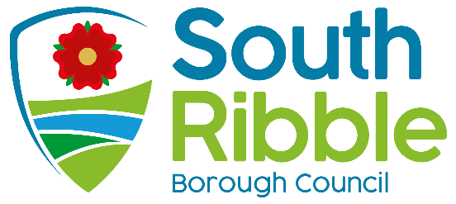

Social Justice Programme 2021/22

Purpose of the Report
- To present Cabinet with the Social Justice Programme. This includes the progress achieved so far.

Recommendations to Cabinet
- That the report be noted.

Reasons for recommendations
- To recognise the Council’s commitment to social justice through the delivery of the Corporate Strategy.

Other options considered and rejected
- No other options have been considered or rejected.

Corporate priorities
- The report relates to the following corporate priorities: (please bold all those applicable):

An exemplary council | Thriving communities
A fair local economy that works for everyone | Good homes, green spaces, healthy places

Background to the report
- In February 2021, the Cabinet Member for Communities, Social Justice and Wealth Building along with the Lead Member for Social Justice and Equality set a commitment to work proactively to further social justice within South Ribble.

- This evolved into the creation of a plan of activity with the aim of improving outcomes in our communities. The Social Justice Programme 2021/22 includes the following three key priorities:

- Enabling social justice through council services,
- Raising awareness and celebrating diversity in South Ribble,
- Supporting access and participation within our communities.

- This report presents the priorities, objectives, actions, and initial progress achieved as well as the long-term ambitions of the programme.

Climate change and air quality
- There are currently no identified climate change or air quality implications identified with the Social Justice Programme 2021/22.

Equality and diversity
- This report concerns the Social Justice Programme 2021/22, which actively seeks to further equality and improve outcomes in our communities. Therefore, the programme will have a positive impact on equality and diversity.

Risk
- The key risks to this programme are primarily the need for partnership working and wider engagement across the community. Internally, delivery will be dependent on cooperation and support from a range of council services as identified in the action plan.

Comments of the Statutory Finance Officer
- The Social Justice Programme 2021/22 currently has no impact on the budget with all activity to be contained within existing resources or requested as needed.

Comments of the Monitoring Officer
- The Social Justice Programme 2021/22 will support us in further fulfilling our duties as a local authority under the Equality Act 2010. There are no other legal implications.

Chris Sinnott
Deputy Chief Executive

Report Author: | Email: | Telephone: | Date:
Jon-James Martin | jon-james.martin@southribble.gov.uk | 01257 516141 | 22/10/2021

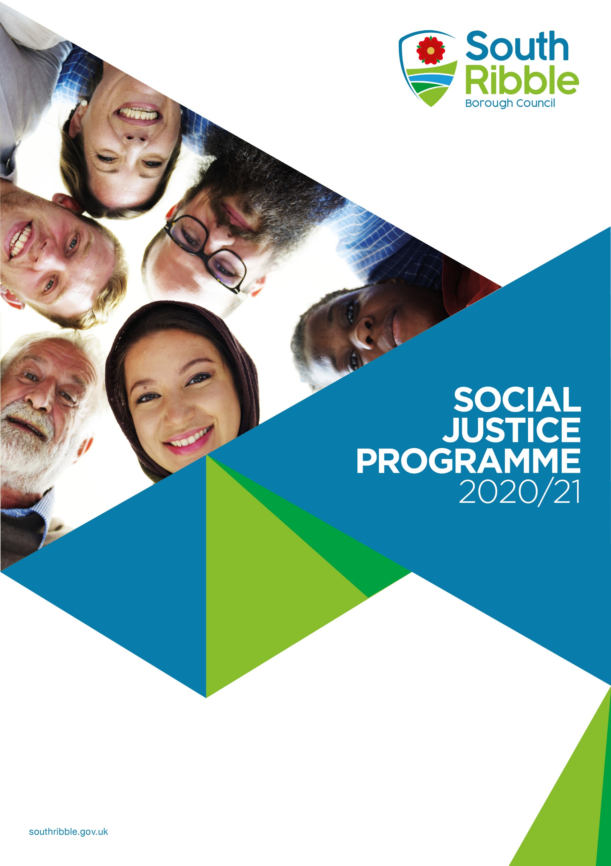

Introduction

Introduction
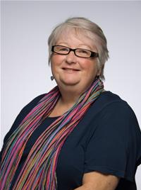
Councillor Jacky Alty
Lead Member for Social Justice and Equality

South Ribble Council has set a vision to achieve “A healthy and happy community, flourishing together in a safer and fairer borough that is led by a council recognised for being innovative, financially sustainable and accountable".
It is at the heart of our council and everything we do. It means a relentless focus on creating the conditions, partnerships, and services that support improvements in the lives of our residents, ensuring they have opportunities to succeed and thrive.

Social justice is about ensuring that each individual is given the opportunity to fulfil their potential and the provision to have individual needs recognised. Giving those who have been marginalised, a voice and therefore building a South Ribble that works for everyone.

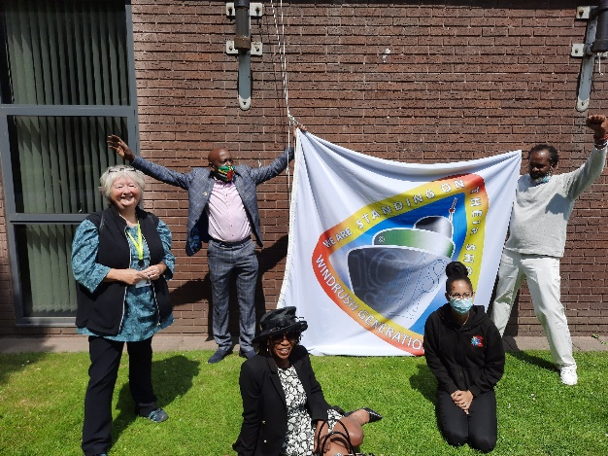
As a local authority, the Council has an incredibly important and unique position to spearhead equality through its role as a service provider, employer, and community leader. The Social Justice Programme 2021/22 is determined to promote equality both within our organisation as well as in our local community. In my role as Lead Member for Social Justice and Equality, it is my aim to raise our profile and develop a reputation for tackling inequality and injustice.

A strong commitment to equality does not only have a compelling moral argument, but it also makes good business sense. By considering the needs and aspirations of a diverse community, it ensures we deliver high quality and accessible services. It will also ensure that those communities can enjoy increasingly fulfilling lives.

“It is vital that we place accessibility in the heart of everything that we do to ensure that South Ribble works for everyone and that everyone can fulfill their potential”.

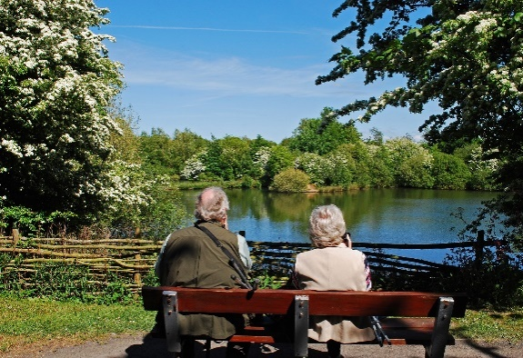
Background and Context
In February 2021, the Cabinet Member for Communities, Social Justice and Wealth Building along with the Lead Member for Social Justice and Equality set a commitment to work proactively to further social justice within South Ribble.
This evolved into the creation of the Social Justice Programme, which establishes a set of priorities and actions what we will be delivering in order to improve outcomes in our communities and foster a fairer society within South Ribble.
The programme exists within a context of ever changing communities, who have a diverse set of needs. These unique needs must be accounted for if we are to continue to deliver effective and high-quality services and support residents to live happy and healthy lives.

Our Strategy
Our Strategy

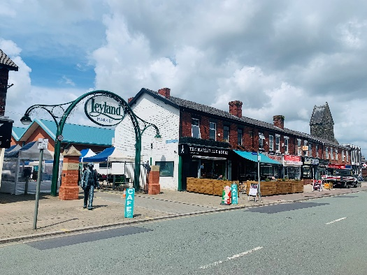

Priorities
As part of the Social Justice Programme 2021/22, we have established a set of three priorities. These priorities outline what will be delivered as part of the programme and include the following:
Priority One: Enabling social justice through council services
As a community leader with responsibility for designing and delivering services, the council has a fundamental role to play in promoting social justice to achieve better outcomes for individuals and families right across the borough.

As those that work closely with communities, it is our staff, councillors and partners that can influence participation and collaboration so that decisions are shaped by the borough, for the borough.

To do this, we will need to have a collective understanding of the challenges, opportunities and priorities for action. We also need to set out what to do, and how to do it, with some clear guidelines and expectations.

Objectives:
- Set out equality and diversity priorities and objectives for South Ribble for the next 3 years,

- Ensure clear processes and policies are in place and consistently applied through training and development of officers and members,

- Review and monitor our performance at least annually.

Priority Two: Raising awareness and celebrating diversity in South Ribble
South Ribble is a diverse borough made up of new and old, urban and rural, young and old. Recognising the role of difference and diversity is vital to achieving cohesive and inclusive communities.

To do this we need to highlight the value of individual perspectives and contributions, challenging negative behaviour and promoting positive examples of action to overcome injustice.

Our Strategy

Objectives:
- Celebrate difference and raise awareness of social justice within our communities by recognising national awareness days and promoting them through our external communications channels, including through our website and social media,

- Take a proactive approach to accessibility when organising events and activities in the community to ensure that all groups can participate equally.

Priority Three: Supporting access and participation within our communities
We want everyone in South Ribble to live life to its full potential.

To do this we need to remove the barriers that lead to isolation and exclusion. These barriers are often hidden or unintended and it’s our role to seek them out by engaging, understanding and taking action. As a council we should set the standard for accessibility through the development of our projects, events, plans and policies.

Objectives:
- Engage with our community and when barriers or issues are identified, act upon concerns promptly,

- Consult widely and seek advice from those with real lived experience when preparing new plans and policies,

- Make our buildings, streets and open spaces ‘friendly’ environments for every resident through our plans, policies and projects.

Opportunities in Year One
Within year one of the Social Justice Programme, the following will be delivered:
Priority One: Enabling social justice through council services

Looking Ahead
Looking Ahead

Create an Equality Framework
To create an Equality Framework that defines our equality policy so that we have the right processes to support our social justice ambitions. This will aim to improve how we monitor equality and as well as embed equality into everything we do.

Deliver training to staff and members
To provide staff and elected members with equality training so that they are equipped with the skills necessary to deliver our social justice ambitions. This will support them in understanding their roles and responsibilities.

Priority Two: Raising awareness and celebrating diversity in South Ribble

Establish a calendar of events
To produce a calendar of events that marks key equality related dates for us to promote. This will aim to raise the profile of key issues and facilitate engagement and discussion with residents on equality issues, making the best use of social media.

Ensure Music in the Park is inclusive
To work with the events team to ensure Music in the Park is accessible to all groups and communities. This will make sure that our events are inclusive and reflective of the vibrant and diverse communities throughout the borough.

Priority Three: Supporting access and participation within our communities

Make the Town Deal as accessible as it can be
To aspire for the highest accessibility standards as part of the future Town Deal developments by consulting and engaging with key stakeholders to achieve a flagship town centre for the borough.

Launch a Community Toilet Scheme
To explore a Community Toilet Scheme in partnership with local businesses that can provide access to toilet facilities in the town centre. This will aim to enhance visitors’ quality of life by ensuring that accessible toilet facilities are easily available.

Review unadopted streets
To address the issue of unadopted streets. This will aim to improve the information available to residents of unadopted streets and support them in transforming neglected areas into vibrant community spaces.
Looking Ahead

Consider how new developments can accommodate all needs
To consider how we can ensure that new developments are well designed for all needs with access to community facilities and amenities.

Action Plan
There are further actions that we will be delivering as part of the Social Justice Programme 2021/22 going forward. These actions will continue be based around the three priorities that underpin the programme.

Action | End Date
Develop Member learning hour (Town Deal accessibility) | December 2021
Publish Equality Framework and Impact Assessment | February 2022
Present options for community toilets | February 2022
Launch equality engagement and advice forum | March 2022
Develop Adopt an Alley initiative | March 2022
Deliver Music in the Park | June 2022
Analyse Census 2021 (no confirmed publication date) | TBD 2022
A summary of actions delivered to date is included in Appendix A.
Moving to Action
Essential to the delivery of the programme will be the support of our key partners, communities, staff, and Councillors. This includes:
- Local charities and organisations to provide advice and support,
- Residents and communities to understand individual needs,
- Councillors to utilise their platform to back and promote the programme,
- Staff to deliver and coordinate the actions,
- Policies and processes to provide the structure to secure and measure equality outcomes.

Progress Update Table
The table presents the actions delivered so far as well as the progress achieved as of October 2021:
Appendix A
Appendix A – Progress Update

Action | Status | Update | End Date

Priority One: Enabling social justice through council services
Create an Equality Framework | The framework has been drafted and will be presented to the Shared Senior Management Team in November 2021 ahead of presentation to Cabinet in February 2022 for final approval. | Ongoing | February 2022
Deliver training to staff and members | Two new equality and diversity e-learning modules have been launched on the Learning Hub for staff and members. This includes ‘Equality in the Workplace’ and the ‘Equality Act 2010’, which now form part our mandatory training package. A performance indicator has been created in order to closely monitor the uptake of the module quarterly to ensure it is implemented effectively, with a target set at 80%. This module will ensure that staff are equipped with the knowledge necessary to support our equality ambitions and future actions. | Ongoing | TBD

Priority Two: Raising awareness and celebrating diversity in South Ribble
Establish a calendar of events | A calendar of events has been produced, identifying dates to promote via our external communication channels. This aims to increase the profile of equality issues, stimulating discussions and community engagement. The dates in the calendar have been selected as they signify equality related dates that link with our corporate and service level projects. | Completed | August 2021
Ensure Music in the Park is inclusive | This action has not yet started. | Not Started | June 2022

Priority Three: Supporting access and participation within our communities
Make the Town Deal as accessible as it can be | Four local equality organisations have been invited to review the plans and provide feedback on key aspects such as accessibility. These plans will be ready for review ahead of December 2021 once they have been finalised by the architects.  The feedback provided by the groups will be used to develop a Member Learning Hour in early 2022 in order to present the feedback. | Ongoing | December 2021
Launch a Community Toilet Scheme | Research has been conducted to investigate how we can improve the provision of accessible toilets in the town centre through working more closely with local businesses, including sources of advice and funding.  A survey will be conducted over August and September to gauge the views of local business, who will be asked whether they would support a proposed Community Toilet Scheme in order to assess the initial reception. | Ongoing | March 2022
Review unadopted streets | An information webpage has been created, which provides up-to-date information on unadopted streets. This includes how to find out if your street is unadopted, links to relevant resources and services, and how to get an unadopted street adopted.  As part of long-term delivery, an Adopt an Alley scheme has been proposed. This will be an initiative aimed at encouraging communities to take ownership of their unadopted street and transform them into healthy and vibrant communal spaces, with residents invited to nominate their neglected backstreet alleyways and volunteers recruited to upgrade the selected spaces | Ongoing | March 2022
Consider how new developments can accommodate all needs | This action has not yet started. | Not Started | March 2022
Appendix A

