Record of Executive Member Decision Taken Under the Scheme of Delegation . | On
 | 7 June 2021
Title |  | Report of
Leyland Market Traders ~ Rent Abatement |  | Cabinet Member (Finance, Property and Assets)

Is this report confidential? | No

Purpose of the Report
- To seek consent for a rent abatement position for Leyland Market Traders.

Recommendations
- It is recommended that Leyland Market Traders be granted an abatement equivalent to their rent for the period 16 February to 12 April 2021.

- It is recommended that the Market café be granted an abatement equivalent to the period 16 February to 17 May 2021.

Reasons for recommendations
- Many of the Leyland Market traders have been required to close during the lockdown resulting from the Covid 19 pandemic. Consequently, several of them have suffered severe financial difficulties. A rent abatement would provide much needed financial support.

Other options considered and rejected
- No alternative action has been considered or is proposed.

Corporate outcomes
- The report relates to the following corporate priorities: (tick all those applicable):

An exemplary council |  | Thriving communities
A fair local economy that works for everyone | $$√$$ | Good homes, green spaces, healthy places

Background to the report
- Because many Leyland Market Traders and the market café have suffered financially during the current lockdown, consent is sought to grant a rent abatement.

Leyland Market Traders ~ Proposed Rent Abatement

- Along with many other local businesses, the Leyland Market traders have expressed deep concern regarding their ability to survive financially while they are required to remain closed as a result of the Covid 19 pandemic.

For the period 4 January to 15 February 2021 all market traders who were required to close were granted a rent abatement by the Council.

Under the current lockdown rules traders are required to remain closed until 12 April 2021.

Consent is sought to grant an additional rent abatement to all market traders who have been required to close to cover the period 16 February to 11 April 2021.

The market is open three days a week, but the market café is open six days a week and is not allowed to open until 17 May. Consequently, their loss is greater and has been calculated separately on the spreadsheet shown in the appendix. Including the café, a rent abatement calculated on this basis would represent a loss to the Council of close to £12,000.

A spreadsheet containing the calculated cost of the abatement is attached as an appendix to this report.

Risk
- If a rent abatement is granted for the proposed period, the Council will lose approximately £12,000 in rent.

Equality and diversity
- There are no equality issues associated with this report.

Comments of the Statutory Finance Officer
- This proposal would compensate traders for closure periods and can be funded from Covid 19 funding 21/22 allocations. It would be appropriate to grant these abatements by way of credits to charges either already in arrears or against future charges to be raised up to the maximum abatement calculated.

Comments of the Monitoring Officer
- There are no issues of concern to raise from a legal point of view.

Background documents

Appendices
Appendix A ~ Spreadsheet detailing the cost to the Council of granting a rent abatement to the café and Market Traders.

Report Author: | Email: | Telephone: | Date:
Russell Cain  (Senior Estates Surveyor) | russell.cain@southribble.gov.uk | 01772 (62)5384 | 4.6.21

Following careful consideration and assessment of the contents of this report, I approve the recommendation(s) contained within this report in accordance with my delegated power to make executive decisions.
Signed: | 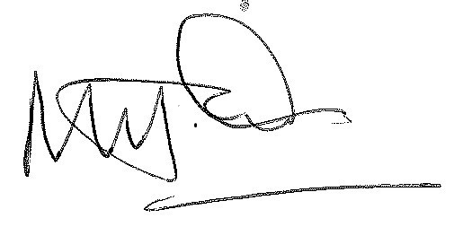
 | Cabinet Member (Finance, Property and Assets)
Date: | 7 June 2021
Publication Date (DSO use only): | 7 June 2021

This decision will come into force and may be implemented five working days after its publication date, subject to being called in in accordance with the Council’s Constitution.

