REPORT TO | ON
Cabinet | 10 February 2021
TITLE | PORTFOLO HOLDER | REPORT OF
McKenzie Arms Development Procurement Strategy Update | Cabinet Member (Finance, Property and Assets) | Director of Commercial

Is this report confidential? | No

Purpose of the Report
- To update the proposed procurement strategy for appointment of a Contractor to deliver the McKenzie Arms development.

Recommendations
- Cabinet approves the procurement strategy to appoint a contractor through an OJEU compliant framework to ensure the appointed contractor is experienced in delivering modular, passivhaus developments.

- Cabinet to approve the delegation of Contract Award to the Cabinet Member (Finance, Property and Assets).

Reasons for recommendations
- To allow the progression of the development that will deliver a passivhaus compliant build.

Other options considered and rejected
- The Council could tender the works via an open procurement route, however due to the specialised nature of delivering passivhaus accredited housing it is advised that an OJEU compliant framework that allows appointment of Contractors who are experienced in delivering modular passivhaus schemes will de-risk this element of the development delivery.

Corporate outcomes
- The report relates to the following corporate priorities: (tick all those applicable):

An exemplary council |  | Thriving communities
A fair local economy that works for everyone |  | Good homes, green spaces, healthy places

Background to the report
- In September 2020 a report was taken to Cabinet that confirmed a request from the Cabinet to undertake an open procurement route evaluated based on cost, quality and social value for the appointment of a Contractor to deliver the scheme.

- The Architect who progressed the design to allow a planning application to be approved has been retained to progress the design to allow a tender package to be prepared and priced by the Contractor. To date the design has been progressed to RIBA Stage 3, and incorporates the following key attributes:
- MHCLG’s Nationally Described Space Standards and meet optional standard Part M4(2) of Building Regulations in future proofing the homes through incorporating accessible and adaptable standards
- Enhanced energy efficiency measures using air source heat pumps
- Modern methods of construction, using Structured Insulated Panels (SIPs) as the main building frame which allows for reduced energy costs for future residents and reduced installation time on-site
- Modelled to achieve Passivhaus Standard which provides a high level of comfort for occupants whilst using very little energy for heating and cooling enabling reduced energy bills
- Modelling has been undertaken using the PHPP which confirms that it is possible for each of the dwellings to reach Passivhaus Standard.

- Since the September 2020 Cabinet meeting, progress has been made to appoint some external project management and quantity surveying support to assist South Ribble to deliver the scheme. This appointment has been undertaken via a waiver to ensure the delivery programme is maintained. Appointment has been made to Gosling Construction Services (GCS) a Leyland based consultancy firm. As part of their appointment GCS were to undertake a critical review of the most appropriate procurement strategy and advise the Council on the most appropriate approach.

- This report sets out this review and the recommended Contractor procurement strategy.

Procurement Strategy
- The proposed procurement strategy has given full consideration of the Councils objectives for the scheme:

- Commencement of site works by third quarter 2021
- Completion of works summer 2022
- Management of the project within the approved budget of £2,217,000, this includes cost expenditure to date and design requirements to meet Passivhaus standards
- Consideration of enhancements to achieve a Passivhaus accreditation, but as a minimum, a design which represents the very highest quality in terms of environmental outcomes
- The use of modern methods of construction to support the targeted environmental standards and deliver construction efficiencies on site
- A procurement route which delivers the key outcomes and is compliant with the Councils Contract Procedure Rules.

- The key drivers are challenged in a number of different ways, such challenges being potentially mitigated by the selected procurement route. Whilst no procurement option will guarantee to address all of the potential challenges in full, selection will be guided by those which are considered to be of most importance.

- The currently identified key challenges are considered to be:
- Securing a Contractor with the expertise and capacity to design, manufacture and deliver a modular building
- Securing a Contractor with the expertise to deliver the Passivhaus / environmentally enhanced standard
- The inflated housing and construction market putting pressure on available resource, pressurising the programme and potentially increasing prices
- The status of the design to support the selected procurement route and the time taken to develop the design to the required stage
- Ensuring that the design is robust enough such that the requirements of Passivhaus accreditation are met in full
- Addressing any pre-commencement issues such as Party Wall, Tree Removal, Overage Rights and funding
- Prior to considering the procurement route for the appointment of a Contractor, it is important to first consider the procurement of the design and the Passivhaus accreditation. It is understood that the Architectural design has been prepared in accordance with the ‘Passive House Planning Package’ (PHPP) which ensures the design is compliant with the stringent requirements of the standard.
- The design has already been developed to RIBA Stage 3 and is cognisant of modular construction as being the optimum choice to achieve the Passivhaus accreditation. A modular build relies heavily on design input from the manufacturer/contractor and it therefore follows that the detailed design should be developed by the specialist.
- It is recommended that the design is developed to a Stage 3 + which would include:
- A developed Architectural scope/specification document, which would accurately reflect and described the enhanced requirements to achieve the Passivhaus accreditation
- A developed MEP scope/specification document, which would accurately reflect and describe the enhanced requirements to achieve the Passivhaus accreditation.
- It is acknowledged that the selected Contractor procurement method will need to be:
- OJEU compliant
- Be compliant with the Councils Procurement Rules
- Deliver against the key project objectives
- Address the challenges highlighted previously in this report.
- Provide social value to the Council.

- The procurement strategies considered are set out below;

- Traditional: design developed to RIBA Stage 4 by the technical team and open tenders invited based on a Bill of Quantities or Approximate Quantities.
Advantages | Disadvantages
Greater control over design and variations to the scope | Longer procurement period and later start on site
More straightforward appraisal of prices due to consistency of tender documentation | Reliance on accuracy of contract documents
Control over product selection and finish | Lose the opportunity for early Contractor / specialist engagement and added value
 | Council retain majority of design risk
 | Contractor bears no design risk
 | Risk of achieving the Passivhaus accreditation remains with SRC

Recommendation: not considered the optimum procurement solution for the scheme, due to the length of time in procurement and the requirement to involve the specialist in the development of the modular design.

- Design & Build: Employers Requirements / Specification documents developed by the technical team and open tenders invited based on a Contract Sum Analysis and Contractor design
Advantages | Disadvantages
Greater risk transfer to the Contractor, including the requirement to achieve the Passivhaus certification | Variations to the scope more difficult to value and can be more costly
Cost and time certainty | Appraisal of tenders can be more difficult if the documentation is not robust, potential for greater derogation
Quicker start on site | Potential cost inflation due to the increased risk profile assumed by the Contractor
Early Contractor engagement and support with regard to the development of the modular construction requirements
Less Client side admin requirements
More focussed responsibility for the Client team

Recommendation: that a Contractor be appointed on the basis of a Design and Build contract, allowing the specialist design to be developed, a more straightforward tender process and an earlier commencement on site.
- Other possibilities considered and discounted:
- Target cost: lack of cost control.

- Consideration also needs to be given on whether a single stage or two stage tender process should be used. The ideal option would be to issue tenders on the basis of single stage appointment, obtaining a fixed price from the market at the earliest opportunity and allowing the Stage 4 design to progress prior to site works commencing. Whilst this is the aspiration, it is acknowledged that the market preference, in order to de-risk projects from the Contractor side, is to seek appointment on a 2-stage basis and develop the price on an ‘open book’ basis. It is proposed that the market be tested through Expressions of Interest based on a single stage design and build tender approach and prepare for the need to flex the approach to a 2-stage tender if the market dictates this.

- Given the type of project, the volatility in the market, the probability that appropriate resource exists within the locality and the specialist nature of the modular construction, an open tender via the chest is not the recommended route for the selection of a tender cohort and an appropriate framework is proposed. The suitability and capacity of the frameworks would need to be interrogated swiftly and the team be prepared to flex the approach to an open tender if a suitable framework partner could not be found. It is recommended that one of the specialist modular house-building frameworks is utilised. The framework to be used will be dependent on the outcome of the Expression of Interest review and the framework that can provide terms that a favourable to the Council.
- The contractors tendering under the framework would be subject to a rigorous evaluation process using the Most Economically Advantageous Tender (MEAT) assessment process. The assessment process will be as follows:

- 60% Cost - The tenderer with the lowest cost would be awarded the full 60% cost score. Other bids would be awarded a percentage score pro-rata to this using the following formula: Total Lowest Bid Cost/ Total Individual Bid Cost x 50 (rounded to two decimal places)
- 40% Quality – specific questions aimed at establishing the ability to deliver to the required quality, social value, health and safety and environmental outcomes on the scheme.

- It is recognised that demonstrating and delivering social value and monitoring environmental impacts is a key element of the Contractor appointment, it is therefore proposed that as part of the quality submission the contractor will be requested to demonstrate the following:
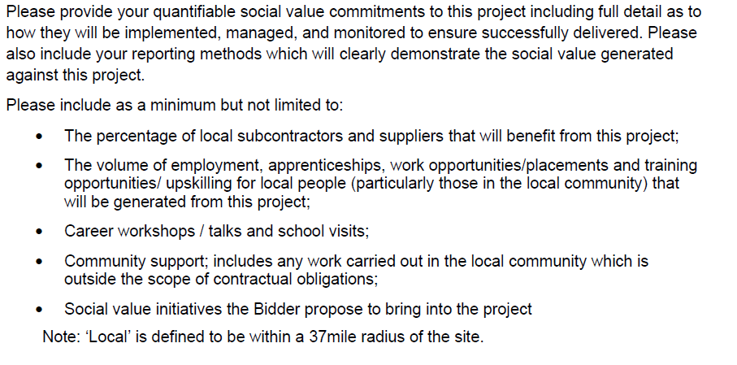
- The environmental benefit will be agreed through a series of key performance indicators such as waste diverted from landfill.

- The recommended procurement strategy for the appointment of a contractor to the deliver the McKenzie Arms development is summarised below.

Delivery Approach | Tender Approach | Tendering Platform
Design and Build | Single Stage (building in flexibility to allow two -stage if the market dictates this approach) | Framework. Chosen framework to include contractors who specialise in modular and passivhaus build.

Programme
- The tendering programme has been developed to allow a commencement on site in July 2021. The key activities and milestones are set out below:
Activity | Milestone
Develop design and tender documentation | 05 March 2021
Tendering Period | 16 April 2021
Tender Review and Recommendations | 30 April 2021
Develop detailed Design with appointed Contractor | 09 July 2021
Commence Construction on site | 26 July 2021
Works Completion | 25 March 2022

Risk

27. See table below

Air quality implications

- The proposed development site is located within an identified Air Quality Management Area (AQMA) but also presents a sustainable location close to Bamber Bridge centre offering existing alternative transport links.

- Air Quality has been a material consideration throughout the planning process and an air quality assessment undertaken through consultation with the Councils Environmental Health department. Measures have been agreed through the planning process to address air quality concerns supported by Environmental Health.

Comments of the Statutory Finance Officer
30.The proposed procurement route is to utilise an OJEU compliant framework, seeking fixed price bids on a single stage Design & Build basis.
This offers a number of benefits;
- Targets specialised contractors
- Secures early appointment of a contractor
- Mitigates financial risk for the Council

31.The project will be managed via an External Project Manager who has undertaken to ensure compliance with the Council’s Contract Procedure Rules.
- This scheme is included in the Capital Programme, and once received, tenders will be assessed against the available budget.

Comments of the Monitoring Officer
- The proposed procurement strategy is compliant with both legislation and the Council’s contract procedure rules. The report acknowledges that the proposal departs from the cabinet decision of September last year but provides detailed and cogent reasons for doing so, referencing the benefits of the strategy and compliance with desired council outcomes.

- The proposed scoring split 60:40 cost:quality is appropriate given the proposal to use specialist contractors for the delivering of the passivehaus scheme.

- It should also be noted that social benefit and environmental impact are specifically referenced in the quality element and will be scored as part of the assessment of the bid.
Background documents
There are no background papers to this report.

Appendices
n/a
Mark Lester
Director of Commercial Services

Report Author: Rachel Salter | Email: Rachel.salter@chorley.gov.uk | Telephone: 01257 515 332 | Date: 19.01.21

