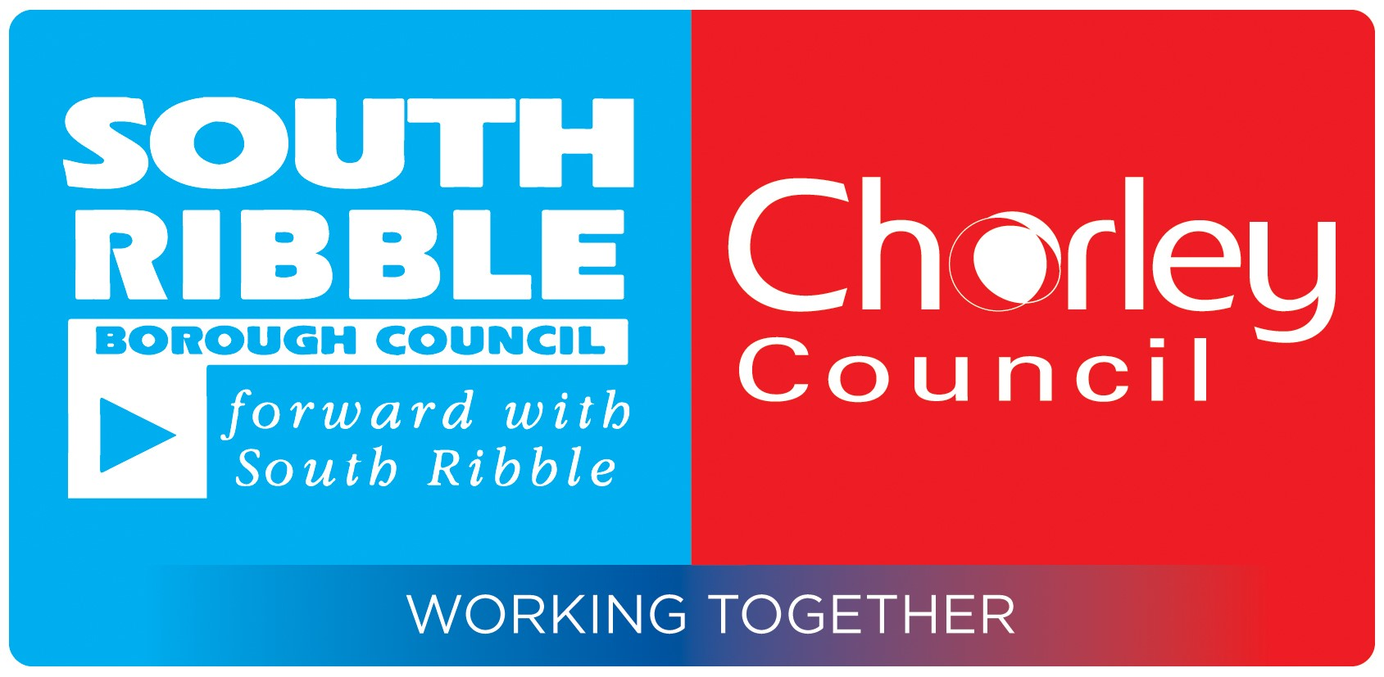

| Report of | **Meeting** | **Date** |
| --- | --- | --- |
| Deputy Director of Finance (Section 151 Officer) | Shared Services Joint Committee | Wednesday 13 January 2021 |

Financial Update

|  |
| --- |
| **PURPOSE OF REPORT** |
| 1. This report provides an update on the budget position of Shared Services following implementation of Phase 1 reviews. |
| **RECOMMENDATION(S)** |
| 1. It is recommended that members note the current split of budgets within Shared Services and the ongoing budget alignment work. |

EXECUTIVE SUMMARY OF REPORT

1. The report summarises the budgets that fall within Shared Services following the Phase 1 reviews.

|  |  |  |
| --- | --- | --- |
| **Confidential report**  Please bold as appropriate | Yes | **No** |

**CORPORATE PRIORITIES**

1. This report relates to the following Strategic Objectives:

|  |  |  |  |
| --- | --- | --- | --- |
| Involving residents in improving their local area and equality of access for all |  | A strong local economy |  |
| Clean, safe and healthy homes and communities |  | An ambitious council that does more to meet the needs of residents and the local area |  |

**background**

1. Shared Services has expanded significantly to encompass a significant level of budget areas. With the Phase 2 reports recently approved there is now in excess of £7m of budgets in this area.
2. Previous reports have detailed the savings resulting from these reviews. Table 1 below summarises these savings.

Table 1: Summary of Shared Service Savings To Date



**BREAKDOWN OF SHARED SERVICES BUDGETS**

1. Shared Services has expanded significantly in the last few months. Table 2 illustrates the total of budgets now within Shared Services and where the budgets is managed across the two Councils.Note this is not the contribution from each Council but where budgets are managed – in a service able to be completed shared the budgets would all be managed at the ‘host’ authority.

Table 2: Shared Services Budgets by Authority Hosting



1. The table illustrates that where the service is hosted within a Council the vast majority of budgets are also managed within that authority as the majority of budgets shared so far relate to staffing. For all of the budgets that are shared a relevant contribution is made as detailed in below. This is especially true for Shared Financial Services which due to the length of time sharing those services the budgets have been aligned to the point that those remaining outside the host authority are only those that cannot be managed outside of it (in this case largely audit fees and direct treasury charges).
2. The contributions to each service by Council varies considerably due to a few factors. There are a number of budgets which are exclusive to a particular Council and these largely fall into the Communications and Visitor Economy section where budgets for Astley Hall and Chorley events are held meaning a greater contribution required to the service. In Governance budgets for Civic Services and buildings are held within the Department for Chorley but not at South Ribble again meaning a greater overall contribution required by Chorley for services exclusive to that Council..

Table 3: Budgets by Contribution



1. Reviews undertaken to date have largely focused on staffing budgets. Of the services reviewed to date this has been the majority of costs involved so non-staffing costs have not required much investigation.
2. Work is now ongoing to identify whether it is possible to bring together non-staffing budgets across the two Councils. Some budgets will not be possible to combine for either; legal reasons, services relating 100% to one Council area or due to differing approaches within each Council. Other budgets will become more aligned as Shared Service processes develop and this should make them easier to combine.
3. The overwhelming majority of budgets are either split 50/50 or 100% recharged to the other Council where the whole of that service or specific charge element is only relevant to it. There are very few current exceptions to this. Current exceptions in shared service staffing teams include:

* Shared Financial Services - The Management accounts team in Shared Financial Service is current charged as per the staff working on each Council. Following a recent review this will be aligned from 2021/22 budgets and will become 50/50.
* Communication and Visitor Economy – the Events Team review is attached with these papers detailing a proposed split.
* Communication and Visitor Economy – the Museum, Tourism and Culture team is split according to the services delivered.
* Transformation and Partnerships – There are three posts specific to Chorley within Programme Management.
* Governance – The Licensing Team is currently included within South Ribble although will be changing following recent Director Reviews.
* Governance – There is a Health and Safety post at Chorley for which there was no direct equivalent at South Ribble within the shared Governance directorate.

1. Over 21/22 budgets will be examined and proposals to combine or align brought forward if appropriate.

**IMPLICATIONS OF REPORT**

1. This report has implications in the following areas and the relevant Directors’ comments are included:

|  |  |  |  |
| --- | --- | --- | --- |
| Finance | X | Customer Services |  |
| Human Resources |  | Equality and Diversity |  |
| Legal | x | Integrated Impact Assessment required? |  |
| No significant implications in this area |  | Policy and Communications |  |

**COMMENTS OF THE STATUTORY FINANCE OFFICER**

1. Financial implications are as detailed in this report.

**COMMENTS OF THE MONITORING OFFICER**

1. No Comments

JAMES THOMSON

DEPUTY DIRECTOR OF FINANCE

|  |  |  |  |  |
| --- | --- | --- | --- | --- |
|  | |  |  | |
| **Report Author** | **Ext** | | | **Date** | |
| Neil Halton |  | | | 21/12/20 | |