Application Number | 07/2020/00853/COU
Address | Penwortham Arts Centre  The Venue  Liverpool Road  Penwortham  Preston  Lancashire  PR1 9XE
Applicant | Penwortham Town Council
Agent | Steve Caswell  Kingsfold Community Centre  Kingsfold Drive  Penwortham  Preston  Lancashire  PR1 9EQ
Development | Retrospective Change of Use from Library to an Arts and Community Use Centre (Sui Generis)
Officer Recommendation  Officer Name | Approval with Conditions  Mrs Janice Crook
Date application valid | 14.10.2020
Target Determination Date | 09.12.2020
Extension of Time
Location Plan

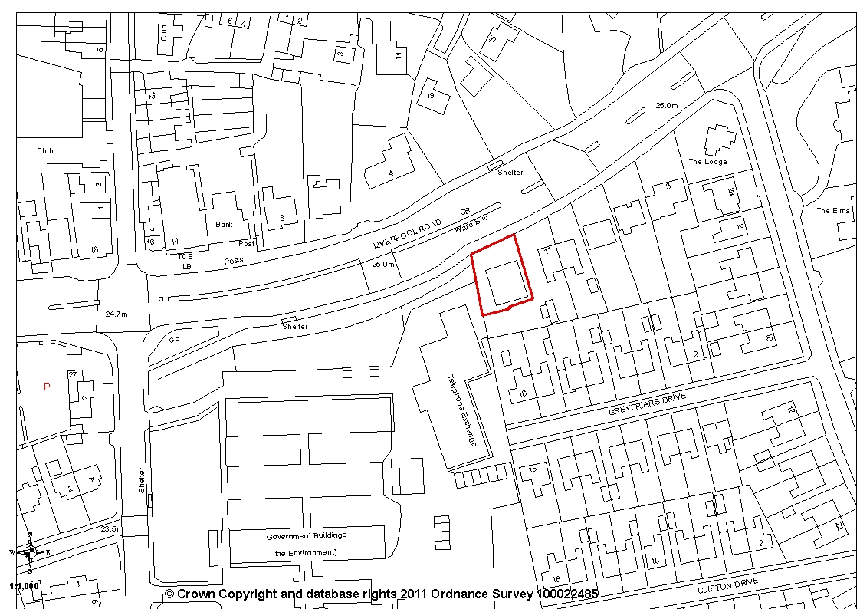
- Report Summary

  - The application is retrospective for the use of the former library building on Liverpool Road to be used for community use within a Sui Generis use class. The use commenced in September 2019 and is known as The Venue and provides a number of regular events with some additional events proposed.

  - The library building is outside of the Penwortham District Centre but the area is a mix of commercial and residential properties and is within the existing built-up area of Penwortham

  - There are no objections from consultees or residents. The proposal is considered appropriate and the application is recommended for approval subject to the imposition of conditions.

- Site and Surrounding Area

  - The application relates to the former library building on Liverpool Road in Penwortham. The library closed in September 2016. The building is within the Existing Built up Area with the Penwortham District Centre lying some 70m to the west.

  - To the south are residential properties on Greyfriars Drive, to the south-west is a telephone exchange building with the former Government Offices site beyond. Planning permission for a new Tesco supermarket has been granted for this site and is currently under construction. To the north is a mix of residential and commercial properties on the opposite side of Liverpool Road and to the east are commercial properties within the District Centre.

- Planning History

3.1 There is no planning history on this site.

- Proposal

  - The application is retrospective for the change of use for the former library to an Arts and Community Use Centre within the Sui Generis use class.

  - The Arts Centre opened in September 2019 and has held regular events including adults and children’s cinema clubs, musical recitals, adults and children’s arts and craft events, history talks, poetry recitals, sing-a-longs, dance session, comedy events and performing artists on Friday or Saturday evenings. There are also a number of ad-hoc events such as art exhibitions, classical music afternoons, jazz jams and workshops.

  - The hours of use are 10:00am until 22:00 every day, although the building will not operate for the full extent of these hours. For example, the building is currently closed on a Monday with regular events taking place between 19:00 and 22:00 on most days.

- Summary of Publicity

5.1 Neighbouring properties were notified and a site notice posted with one letter of representation being received from The Theatres Trust, supporting the application, commenting that the building has been vacant since the previous use ceased in 2016. Maintaining active use of this building is to be welcomed

- Summary of Consultations

  - Environmental Health have reviewed the submitted noise report. They comment that the venue has the potential to generate an adverse impact on neighbouring properties and as such the acoustic consultants have recommended a number of mitigation measures. These have been based on the presumption that sound levels within the venue will not exceed 95dB(A).

  - As such, conditions are required by Environmental Health to ensure that the mitigation measures identified in the Martec report ref: 20200618 8770 Penwortham PEL.docx are fully implemented and evidence of their inclusion be provided to the local planning authority. The evidence is to include details of ventilation measures to ensure windows and doors can remain closed while providing a suitable internal environment. An assessment of any external plant should also be included.

  - Separate conditions are also required to ensure that all doors and windows shall remain closed except for egress and ingress during periods of entertainment, music lessons or other performances; and that the venue shall not be open to the public beyond the hours of 09:00-23:00 Monday to Saturday, 09:00-21:00 on Sundays and Bank holidays.

  - County Highways comment based on all the information provided by the applicant to date and after undertaking a site visit. They are of the opinion that proposals would not have a severe impact on highway safety or capacity within the immediate vicinity of the site. Therefore, County Highways have no objections to the application.

  - They also comment that the site does not provide any off-street parking but it is located within a sustainable location with public car parking in close proximity and parking restrictions in place to control on-street parking.

- Policy Background

7.1 Central Lancashire Core Strategy

Policy 12: Culture and Entertainment Facilities
Plan for culture and entertainment by:
  - Promoting Preston City Centre as a sub-regional centre for cultural and entertainment facilities, with the key service centres of Leyland and Chorley providing for local cultural and entertainment requirements;
  - Protecting existing cultural assets with a view to helping them to adapt to new challenges;
  - Promoting public art and public realm works in town centres and gateways and seeking developer contribution funding where appropriate;
  - Encouraging cultural and heritage based tourism and leisure facilities, such as restaurants, cinemas, theatres and museums, particularly in Preston City Centre.

Policy 17: Design of New Buildings seeks to ensure that new development is sympathetic to surrounding land uses and occupiers and avoids demonstrable harm to the amenities of the local area and that the amenities of occupiers of the new development will not be adversely affect by neighbouring uses and vice versa.

7.2 South Ribble Local Plan

Policy B1: Existing Built-Up Areas permits development proposals for the re-use of undeveloped and unused land and buildings, or for redevelopment, provided that the development complies with the requirements for access, parking and servicing; is in keeping with the character and appearance of the area; and will not adversely affect the amenities of nearby residents.

Policy F1: Parking Standards requires all development proposals to provide car parking and servicing space in accordance with the parking standards adopted by the Council. In general, parking requirements will be kept to the standards as set out unless there are significant road safety or traffic management implications related to the development of the site.
The parking standards should be seen as a guide for developers and any variation from these standards should be supported by local evidence in the form of a transport statement.
Where appropriate, some flexibility will be factored into the standards in relation to the specific local circumstances.

Policy G17: Design Criteria for New Development permits new development, including extensions and free-standing structures, provided that, the proposal does not have a detrimental impact on the existing building, neighbouring buildings or on the street scene by virtue of its design, height, scale, orientation, plot density, massing, proximity, use of materials. Furthermore, the development should not cause harm to neighbouring property by leading to undue overlooking, overshadowing or have an overbearing effect; the layout, design and landscaping of all elements of the proposal, including any internal roads, car parking, footpaths and open spaces, are of a high quality and will provide an interesting visual environment which respects the character of the site and local area; the development would not prejudice highway safety, pedestrian safety, the free flow of traffic, and would not reduce the number of on-site parking spaces to below the standards stated in Policy F1, unless there are other material considerations which justify the reduction such as proximity to a public car park. Furthermore, any new roads and/or pavements provided as part of the development should be to an adoptable standard; the proposal would sustain, conserve and where appropriate enhance the significance, appearance, character and setting of a heritage asset itself and the surrounding historic environment. Where a proposed development would lead to substantial harm or loss of significance of a designated heritage asset, planning permission will only be granted where it can be demonstrated that the substantial public benefits of the proposal outweigh the harm or loss to the asset; and the proposal would not have a detrimental impact on landscape features such as mature trees, hedgerows, ponds and watercourses. In some circumstances where, on balance, it is considered acceptable to remove one or more of these features, then mitigation measures to replace the feature/s will be required either on or off-site.

Policy H1: Protection of Health, Education and Other Community Services and Facilities specifies that development proposing the change of use and/or loss of any premises and/or land currently/ last used as a community facility (including community centres, village and church halls, places of worship, and public houses) will only be permitted where it can be demonstrated that the use no longer serves the needs of the community in which it is located; or the use is no longer financially viable and it has been demonstrated through a marketing exercise or such process agreed with the Council.

- Material Considerations

  - Background
8.1.1 The library service from the application building ceased in September 2016 and the building remained unused for 3 years. Penwortham Town Council then took over the building and, following an internal refurbishment, opened it as an Arts Centre known as The Venue in September 2019 with a variety of uses, including art exhibitions, history talks, history exhibitions and live events with music and poetry. This constituted a change of use of the building and an application was invited.

8.2 Compliance with Policy
8.2.1 The Theatres Trust have made representation and support the proposals commenting that the building has been vacant since the previous use ceased in 2016 and maintaining the active use of this building is to be welcomed. In terms of Local Plan Policy H1, the Trust comments that this policy manages the change of use of community facilities and seeks demonstration and evidence the existing use no longer serves the needs of the community or that it is demonstrably no longer viable. In respect of the library use, although there was opposition to its loss, this replacement facility has been provided. The arts centre is itself a community facility which provides a broad range of functions and therefore it can be considered that there is a net gain in local community provision.

    - Furthermore, Policy 12(d) of the Central Lancashire Core Strategy encourages cultural and leisure facilities, which would include the Arts Centre. Community and cultural facilities of this nature help bring people together and provide opportunities for engagement and participation in the arts. This in turn helps reduce isolation and improves cultural well-being. The Arts centre will also bring people into the area to the benefit of other businesses. The proposal is therefore considered to be compliant with Policy H1 and Core Strategy Policy 12.

    - In principle the new use of the building is also compliant with Policy B1 in that is re-uses a vacant building. However, the proposal must also comply with the requirements for access, parking and servicing; be in keeping with the character and appearance of the area; and not adversely affect the amenities of nearby residents and other relevant policies in the Development Plan.

    - In terms of parking and the requirements of Policy B1a) and policies F1 and G17c), it is acknowledged that there is no dedicated parking for the property. However, the site is close to the Penwortham District Centre where there is a public car park. Additionally, the Tesco Supermarket development to the south-west will also provide an element of public car parking, with condition 12 of planning approval 07/2016/1171/FUL securing the details.

    - County Highways have no objections to the proposals and consider the proposals would not have a severe impact on highway safety or capacity within the immediate vicinity of the site. However, County Highway do comment that the site does not provide any off street parking but recognise that it is located within a sustainable location with public car parking in close proximity and parking restrictions in place to control on street parking.

    - In terms of Policy B1b) relating to the character and appearance of the area, the application property is set in a mixed use area with residential and mainly commercial properties along Liverpool Road. There is no overriding style or design of buildings with some commercial properties having recently been refurbished and renovated whilst other remain as existing. No external building works are proposal and the building will remain as existing. Therefore, there will be no impact on the character and appearance of the area.

    - In terms of residential amenity and the requirements of Policy B1 c) and G17 and Core Strategy Policy 17, there are residential properties to the rear on Greyfriars Drive and immediately adjacent Liverpool Road. The venue has the potential to generate an adverse impact on neighbouring properties in terms of noise and disturbance from some of the uses.

    - A Noise Impact Assessment has been submitted with the application by Martec, Ref: 20200618 8770 Penwortham PEL which identifies a number of noise mitigation measures. These have been based on the presumption that sound levels within the venue will not exceed 95dB(A). The report recognises that, should secondary glazing to be installed levels would drop to around 40 LAeq at nearby properties which is lower than the evening background noise levels.

    - The mitigation measures recommended are that:

    - The glazing within the entertainment space of the building should be upgraded such that secondary panes of glass, at least 6mm thick, are installed at least 150mm behind the existing glass, in heavy well-sealed frames, with absorbent material lining the side and top reveals between the inner and outer glass.

    - All windows and doors on the east, south and west facades of the building remain closed during any event involving amplified music entertainment.

    - It may be necessary to arrange for suitable ventilation for the entertainment space, and any such system should not itself either create significant noise, nor should it allow significant levels of internal noise to pass through it and thereby reach residents. Alternatively, it may be possible to arrange for ventilation via the front [north] façade of the building.

    - The report concludes that, on the basis of the above recommendations, the predicted noise levels from the entertainment venue are likely to be acceptable to the nearest residents, and the noise impact should not bar the grant of planning consent for the development.

    - Environmental Health have considered the report and advise that the mitigation measure as outlined in the report must be implemented. Therefore, they require a condition be imposed to ensure the mitigation measure as outlined in the report are implemented and evidence of their inclusion is submitted to the local planning authority within 30 days of the granting of the planning permission. This should also include details of ventilation measures to ensure windows and doors can remain closed while providing a suitable internal environment. An assessment of any external plant should also be included within the submitted information.

    - Environmental Health also require that all doors and windows remain closed except for egress and ingress during periods of entertainment, music lessons or other performances and that the venue should not be open to the public outside the hours of 09:00 to 23:00 Monday to Saturday, and 09:00 to 21:00 on Sundays and Bank Holidays.

    - The hours of use as applied for by the applicant are 10:00am until 22:00 every day, although the building will not operate for the full extent of these hours. For example, the building is currently closed on a Monday with regular events taking place between 19:00 and 22:00 on most days. Therefore, it is considered appropriate to impose the condition in line with the hours applied for, particularly given that there are only afternoon activities on Sundays and the venue is closed on Mondays.

    - It is noted that The Venue has a premises licence with the hours of opening from 08:00 and 22:30 and for the supply of alcohol for consumption on the premises only between noon and 22:30 but the applicant has confirmed that 10am until 10pm every day are the more suitable hours.

- Conclusion

9.1 It is considered that the change of use of the former library building to a community venue is acceptable and with the imposition of conditions, will not unduly impact on the residential amenity of neighbouring properties. It is recognised that the application property it close to the Penwortham District Centre, adjacent the new Tesco supermarket site and opposite a number of drinking establishments and therefore is in an area where the use will be comparable. The proposal has the additional benefit of bringing a vacant building back into use for the benefit of the wider community. Therefore, the application is recommended for approval subject to the imposition of conditions.

- Recommendation

  - Approval with Conditions.

- Recommended Conditions

1. The premises hereby approved shall not be open to the public outside the hours as applied for of 10:00-22:00 on any day.
REASON: In the interests of the amenity of nearby residential properties in accordance with Policy 17 in the Central Lancashire Core Strategy

2. All doors and windows shall remain closed except for egress and ingress during periods of entertainment, music lessons or other performances.
REASON: In the interests of the amenity of the nearby residents in accordance with Policy 17 of the Central Lancashire Core Strategy

3. The mitigation measures identified in the submitted Noise Assessment report by Martec Environmental Consultants Ltd ref: 20200618 8770 Penwortham PEL.docx shall be fully implemented and confirmation of their inclusion shall be submitted to the local planning authority for approval in writing within 1 month of the date of the granting of the planning permission. This mitigation shall include details of ventilation measures to ensure windows and doors can remain closed while providing a suitable internal environment. An assessment of any external plant shall be included within the submitted information.
Reason: In the interests of the amenity of the nearby residents in accordance with Policy 17 of the Central Lancashire Core Strategy

12 Relevant Policy

Central Lancashire Core Strategy
Policy 12: Culture and Entertainment Facilities

Policy 17: Design of New Buildings

South Ribble Local Plan

Policy B1: Existing Built-Up Areas
Policy F1: Parking Standards

Policy G17: Design Criteria for New Development

Policy H1: Protection of Health, Education and Other Community Services and Facilities

