Application Number | 07/2020/00850/COU
Address | 78 Hough Lane  Leyland  Lancashire  PR25 2YB
Applicant | Mr Domenico Chiaramonte - Bella Vieste Ltd
Development | Change of use from optician shop to a hot food takeaway (Sui Generis)
Officer Recommendation  Officer Name | Approval with Conditions  Mrs Janice Crook
Date application valid | 14.10.2020
Target Determination Date | 09.12.2020
Extension of Time
Location Plan

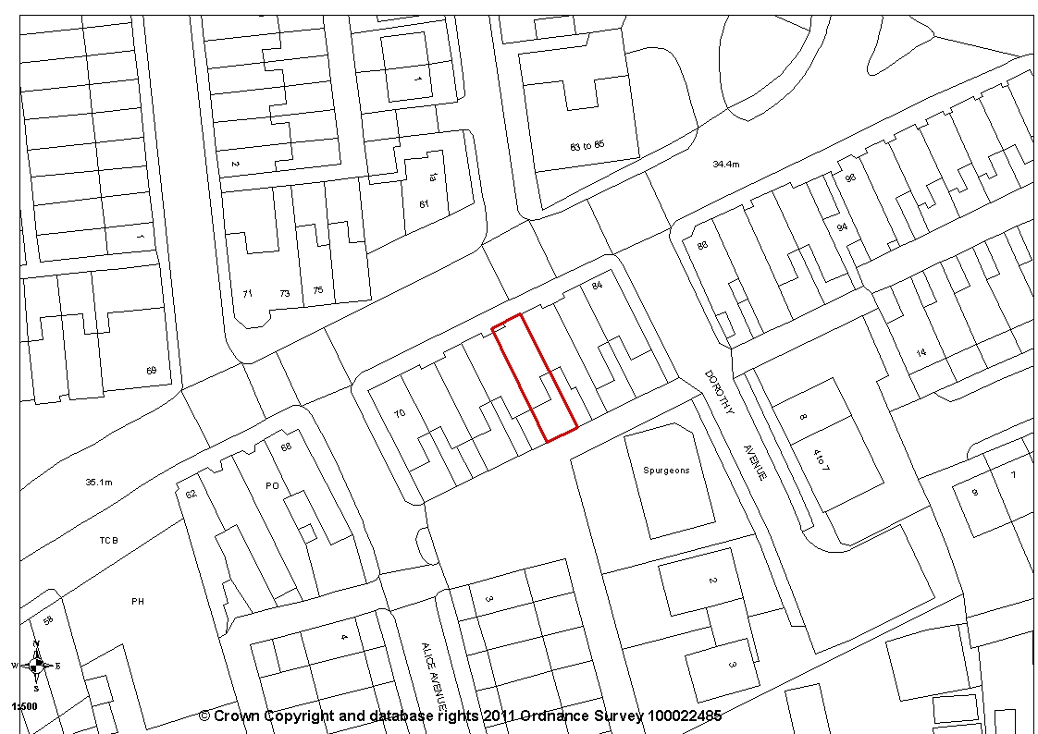

- Report Summary

1.1 The application proposes the change of use from a vacant former optician’s premises to a hot food takeaway, within the Sui Generis use class. The property is within the Leyland Town Centre where one of the aims of Policy E3 is to enhance the evening economy. Although Environmental Health objected to the proposal on the grounds that it has the potential to impact on nearby residential properties, it must be recognised that the proposed use is one which is commonplace in a town centre setting where residential and commercial properties sit in close proximity to each other. With the imposition of suitably worded conditions, it is considered the proposal will not have any impact over and above existing town centre uses, particularly given the reasonable hours of operation applied for.

1.2 The application is recommended for approval subject to the imposition of conditions.

- Site and Surrounding Area

  - The application relates to the commercial premises 78 Hough Lane, Leyland. The property is within the Leyland Town Centre, central in a terrace of commercial properties, some with first floor residential accommodation.

  - Opposite are further commercial properties, to the south-west are residential properties on Alice Avenue and to the south-east are residential properties on Dorothy Avenue together with a charity advice and information centre.

- Planning History

07/2014/0209/FUL for a single storey extension to rear was approved.

- Proposal

  - The application proposes a change of use from a vacant former optician’s premises to a hot food takeaway within a Sui Generis use. There are no external building works proposed.

  - The proposed hours of operation are Tuesday, Wednesday and Sunday 4pm - 9:30pm; Thursday, Friday and Saturday 4pm - 10:30 with no opening on a Monday. The premises will also be closed on all Bank Holidays.

  - The proposal will employ 7 members of staff full time.

  - To the rear is an enclosed back yard which has the capacity for waste bins.

- Summary of Publicity

- Neighbouring properties were notified and a site notice posted with no letters of representation being received.

- Summary of Consultations

  - Environmental Health initially objected to the proposed development on the grounds of insufficient information, commenting that the development has the potential to adversely affect neighbouring properties by way of noise and odour. They advised there has been no assessment of the impact from the proposed use on the neighbouring properties, specifically from the extraction system, but also from patrons, deliveries and staff.

  - This was raised with the applicant and details were submitted of the proposed extraction system. Environmental Health considered this and advised that an odour assessment, noise assessment and plan of where the extraction will terminate would still be required. Although an odour assessment was submitted, this was too late in the process to enable Environmental Health to fully consider it. This is discussed in more detail later in this report.

  - County Highways are of the opinion that proposals would not have a severe impact on highway safety or capacity within the immediate vicinity of the site. Therefore, they have no objections to the application. However, they do comment that the site does not provide any off highway parking but is located within Leyland Town Centre in a highly sustainable location with good access to public transport and on-street parking restrictions to control parking.

- Policy Background

8.1 Central Lancashire Core Strategy Policy 17: Design of New Buildings seeks to ensure that new development is sympathetic to surrounding land uses and occupiers and avoids demonstrable harm to the amenities of the local area and that the amenities of occupiers of the new development will not be adversely affect by neighbouring uses and vice versa.

8.2 Local Plan Policy E3: Leyland Town Centre is made up of both Primary and Secondary Retail Frontages. Within the Primary Retail Frontage, planning permission will be granted for new buildings, redevelopment of existing sites, extensions to, or change of use of existing buildings for the following uses:
- A1 (Retail Uses) which will be encouraged to achieve a minimum of 60% of the overall units within the Primary Retail Frontage;
- A3 (Café and Restaurant) uses and A4 (Drinking Establishments) uses to enhance the evening economy; and
- Other town centre uses including A2 (Financial and Professional Services) and B1 (Offices) will be permitted where this would not harm the sustainability of the shopping area;
- Living accommodation or B1 (Office) use will be permitted at first floor level.

The remaining area of the defined town centre is classified as the Secondary Retail Frontage. Uses in these areas will be protected and enhanced wherever possible for A1 (Retail Use), A3 (Cafés and Restaurants) and A4 (Drinking establishments) may be appropriate to maintain the vitality and viability of the area. (NB: It must be noted that a recent change to the Use Classes Order in July now means that what was formerly an A5 use, along with A4 uses, are now classed as Sui Generis.)

New buildings, redevelopment of existing sites, extensions and/or change of use of existing buildings in the Town Centre will either be expected to use existing car parking facilities within the town centre or provide the appropriate level of car parking based on their location and type of development as set out in Policy F1

8.3 Policy F1: Parking Standards requires all development proposals to provide car parking and servicing space in accordance with the parking standards adopted by the Council. In general, parking requirements will be kept to the standards as set out unless there are significant road safety or traffic management implications related to the development of the site.
The parking standards should be seen as a guide for developers and any variation from these standards should be supported by local evidence in the form of a transport statement.
Where appropriate, some flexibility will be factored into the standards in relation to the specific local circumstances.

- Material Considerations

  - The application property is within the Secondary Retail Frontage of the Leyland Town Centre as defined by Policy E3. Uses in this area will be protected and enhanced wherever possible for A1 (Retail Use) with A3 (Cafés and Restaurants) and A4 (Drinking establishments) being considered appropriate in order to maintain the vitality and viability of the area. The proposal is for a hot food pizza takeaway which would have been a Class A5 use but following a recent change to the Use Classes Order, is now within a Sui Generis use and therefore not within the Use Classes identified as appropriate use in the Town Centre. The Local Plan is silent on the appropriateness of Class A5 uses other than reference in the supporting text to the Leyland Masterplan published in 2007 which recognises other town centre uses (e.g. A2, B1, A5) could be appropriate to support the overall future as a vital and viable town centre.

  - The overall aim of Policy E3 is to protect A1 retail uses with cafes and restaurants acting as complementary uses to the daytime shopping facilities whilst restaurants and pub establishments would support the evening economy. It is considered the proposal would support the evening economy by providing a take away service in the Town Centre which operates from 4pm until 10.30pm.

  - In terms of parking provision, Policy E3 requires that change of use of existing buildings in the Town Centre will either be expected to use existing car parking facilities within the town centre or provide the appropriate level of car parking based on their location and type of development as set out in Policy F1. In this case there is no dedicated parking for the premises. However, there is town centre car park just 40m to the north-east.

  - County Highway acknowledge that the site does not provide any off highway parking but recognised that it is located within Leyland Town Centre in a highly sustainable location with good access to public transport and on-street parking restrictions to control parking. Therefore, County Highways have no objections to the proposal.

  - In terms of residential amenity, it is noted that a number of commercial properties in the immediate area have first floor residential accommodation. However, from the case officer’s site visit, it appeared that the first floor accommodation was vacant and the neighbouring properties mainly had commercial use at first floor. To the south-west are residential properties on Alice Avenue and to the south-east are residential properties on Dorothy Avenue.

  - Environmental Health have objected on the grounds that the proposal has the potential to impact on these residential properties. They initially commented that insufficient information had been submitted and that there was no assessment of the impact from the proposed use on the neighbouring properties, specifically from the extraction system, but also from patrons, deliveries and staff.

  - In terms of extraction, the applicant provided details, advising that his engineer had advised that the most suitable was the SV1216CH SmartVent, canopy extraction ventilation system with a central fan, horizontally mounted and 0.12 kW. The applicant was also advised that an extractor fan/chimney was not required as they will not be using gas and will only be using small electrical appliances.

  - The details were forwarded to Environmental Health for further comment and they advised that an odour assessment, noise assessment and plan of where the extraction will terminate would still be required. The applicant was advised of this and provided comment. He initially advised that, at the moment there are no cooking facilities or kitchen due to not yet having planning permission. Therefore, it would be difficult for accurate assessments to be completed and that this should be done once it is known which appliances are to be installed. However, the submitted plan shows the proposed layout and includes a fryer, 4 ring cooker and a pizza oven with the extraction system overhead.

  - An odour assessment was then carried out and submitted and this was forwarded to Environmental Health for consideration. However, this was too late in the process to allow for Environmental Health to fully consider it before completion of this report. Any response will be reported verbally to planning committee. However, Given that the applicant has advised that final cooking facilities are yet to be decided, it is considered more appropriate to impose a condition requiring that, prior to the installation of any external plant or plant terminating externally, full details be submitted of the siting, noise levels and potential odour impact to be experienced at the nearest properties. This would ensure that any mitigation for any noise and odour from the extraction would be bespoke to the installed facilities.

  - In terms of the impact from patrons, deliveries and staff, it must be recognised that the property is within the Leyland Town Centre where there are a number of similar uses and other businesses which require deliveries and have patrons and staff. All are within relatively close proximity to residential properties. For example, The Leyland Chop Suey House on the corner of Hough Lane and Alice Avenue, a residential street, five properties to the east, is open until 22:30 during the week and 23:00 on Friday and Saturdays.

  - Members will be aware of the recent bid for funding submitted by Leyland Town Board for Leyland town centre improvements with the aim to create “a new vibrant heart to the town and the creation of two new public spaces for Leyland as a new focus for people and events”. Included as part of these proposals, is the aim for commercial development opportunities to diversify the town centre’s offer including commercial units for food and drink and town centre living. The proposal therefore accords with the aims of the town centre improvement proposals.

- Conclusion

  - Although it is recognised that the proposal has the potential to impact on neighbouring residential properties in terms of noise and odour, it is considered that it would not be appropriate to refuse planning permission for this proposal given its location within the Town Centre and the fact that similar properties operate in the area, particularly given that the hours applied for are until 21:30 during the week and 22:30 on Friday and Saturdays. These are not considered unduly anti-social hours. However, it is considered appropriate to impose a condition requiring the submission of details of any external plant prior to first use of the premises to ensure that there are no noise and/or odour issues arising from the proposed change of use.

  - Additionally, there is a need to support local businesses and help maintain the viability of our town and district centres. The proposal brings a currently vacant property back into use to the benefit of the town centre. For these reasons it is considered the proposal is acceptable and the application is recommended for approval subject to the imposition of conditions.

- Recommendation

  - Approval with Conditions.

- Recommended Condition

1. The development hereby permitted must be begun not later than the expiration of three years beginning with the date of this permission.
REASON: Required to be imposed pursuant to Section 91 of the Town and Country Planning Act 1990.

2. Prior to the installation of any external plant or plant terminating externally, full details of the siting, noise levels and potential odour impact to be experienced at the nearest properties and the fixings to be used shall be provided to the local planning authority for written approval. The approved system shall then be installed as agreed and thereafter maintained as approved. Any changes to the system shall first be agreed with the local planning authority in writing.
REASON: In the interests of the amenity and to safe guard the living conditions of the nearby residents in accordance with Policy 17 in the Central Lancashire Core Strategy.

13 Relevant Policy

South Ribble Local Plan
E3 Leyland Town Centre

Central Lancashire Core Strategy
17 Design of New Buildings

