Performance Data

Quarter 2 2020-21

Key Information
This report forms part of the appendices of the “Performance Monitoring Report” update to the Scrutiny Budget and Performance Panel, and Cabinet on the progress at the end of quarter two (July - September 2020) of the Corporate Strategy approved 30th September 2020.

The corporate strategy priorities, are:
- An exemplary council;
- Thriving communities;
- A fair local economy that works for everyone;
- Good homes, green spaces, healthy places.
Within each section is a summary of all activities and their performance status at the end of Quarter 1.
Performance Key

A red, amber, green rating system is used to indicate status whereby:
RED | Off track
AMBER | Forecast delays or concerns, an early warning of issues
GREEN | On track and progressing as planning

Performance Indicators Direction
 | Amber arrows indicate the direction is negative and heading away from the target or is lower than its previous reporting period.
 | Green arrows indicate the direction is positive and improving or heading towards target.

A COUNCIL THAT:
Delivers high performing services that represent value for money | Understand the community and work with partners to make things better | Is open and transparent in its activities

Our Key Performance Indicators:

Key Performance Indicator | Target | Comparable Period | Quarter 2  2020/21 | Direction | Status
At least 40% of service requests will be received via self-service channels | 40% | 37%  (Q1:2020/21) | 32% |  | GREEN

Quarter 2 Project Status
 | 2020-21
Projects | Quarter 2  July - Sep
Deliver the Annual Governance Statement Action Plan | GREEN
Transform the way the council operates | GREEN
Deliver year one of the joint digital strategy | NOT YET STARTED
Work with partners to design and deliver better public service: | GREEN

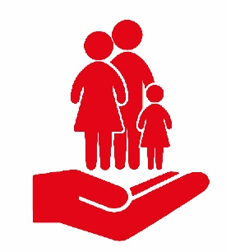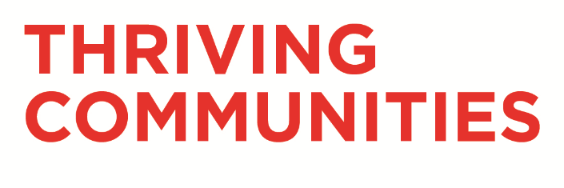

A PLACE WHERE:
Residents have positive mental health | People get involved and have a sense of belonging | Communities can access services and support when they need them

Our Key Performance Indicators
None are reported this quarter

Quarter 2 Project Status
 | 2020-21
Projects | Quarter 2  July - Sep
Establish South Ribble Together Hubs | GREEN
Deliver a mental health support programme for young people | NOT YET STARTED
Establish a youth council | NOT YET STARTED

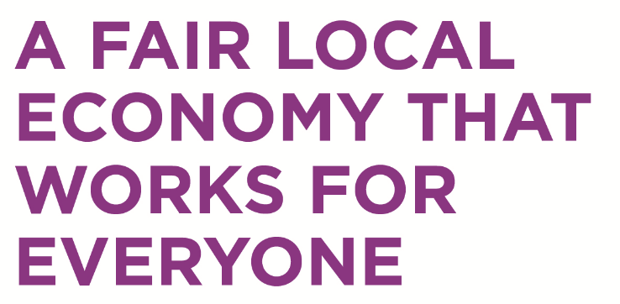

A COUNCIL THAT:
Increases access to training and jobs | Grows and supports sustainable businesses | Invests in improving the borough

Our Key Performance Indicators
Key Performance Indicator | Baseline /  Target | Quarter 1 2020/21 | Quarter 2  2020/21 | Direction |  | Status
Overall employment rate greater than north west average | 74.9% | 87.4 | 84.8 |  |  | GREEN
% 16 -17 year olds not in education or training (NEET) | 3.5% | 3% | - |  | GREEN

Quarter 2 Project Status
 | 2020-21
Projects | Quarter 2  July - Sep
Implement the community wealth building action plan | NOT YET STARTED
Establish a business support programme | NOT YET STARTED
Deliver year 1 of the Town Deal | GREEN

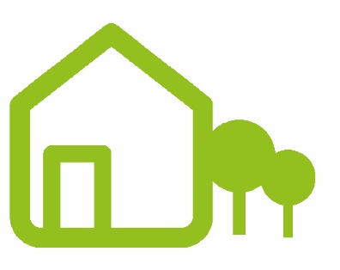

A BOROUGH WITH:
A choice of decent, affordable housing | Commitment to protecting the local environment | A choice of quality recreational activities

Our Key Performance Indicators
Key Performance Indicator | Baseline /Target | Comparable Period | Quarter 2  2020/21 | Direction | Status
Number of affordable homes delivered (bi-annual) | 80  (Target) | 81  (Q4:2020/21) | 12 |  | AMBER
27,500 Trees will be planted in the borough this year | 27,000  (Target) | 459  (Q1:2020/21) | 3,059  (running total) |  | GREEN
The number of people who are prevented from becoming homeless is increased | 341  (2018/19) | 69  (Q1:2020/21) | 90 |  | AMBER

Quarter 2 Project Status
 | 2020-21
Projects | Quarter 2  July - Sep
Bring Worden Hall back into use | GREEN
Deliver a project to support the green agenda | NOT YET STARTED
Deliver a leisure improvement project | GREEN
Commence building of affordable homes within the borough | GREEN

